BIOS User Guide
A70MD PRO / A68MD PRO / A70MG PRO

BIOS Update 2 UEFI BIOS Setup 6 1 Main Menu 7 2 Advanced Menu 8 3 Chipset Menu 18 4 Boot Menu 23 5 Security Menu 27 6 Performance Menu 29 7 Exit Menu33

BIOS Update
The BIOS can be updated using either of the following utilities:
- BIOSTAR BIOS Flasher: Using this utility, the BIOS can be updated from a file on a hard disk, a USB drive (a flash drive or a USB hard drive), or a CD-ROM.
- BIOSTAR BIOS Update Utility: It enables automated updating while in the Windows environment. Using this utility, the BIOS can be updated from a file on a hard disk, a USB drive (a flash drive or a USB hard drive), or a CD-ROM, or from the file location on the Web. BIOSTAR BIOS Flasher
Note
» This utility only allows storage device with FAT32/16 format and single partition.
» Shutting down or resetting the system while updating the BIOS will lead to system boot failure.
Updating BIOS with BIOSTAR BIOS Flasher
- Go to the website to download the latest BIOS file for the motherboard.
- Then, copy and save the BIOS file into a USB flash (pen) drive.
- Insert the USB pen drive that contains the BIOS file to the USB port.
- Power on or reset the computer and then press <F12> during the POST process.
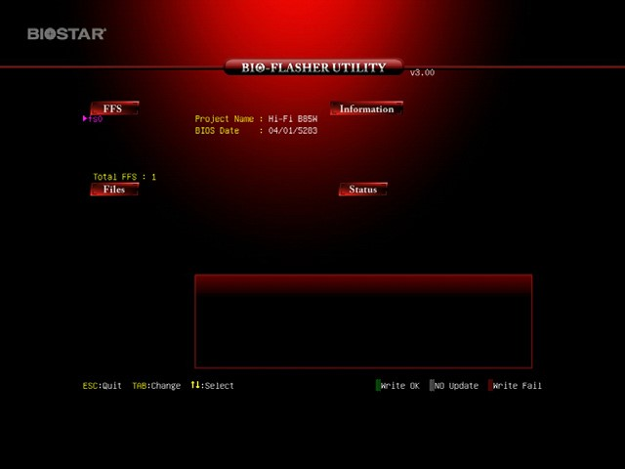
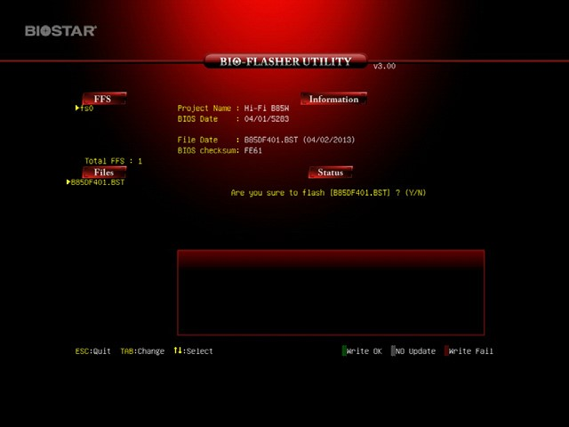
- After entering the POST screen, the BIOSFLASHER utility pops out. Choose <fs0> to search for the BIOS file.
- Select the proper BIOS file, and a message asking if you are sure to flash the BIOS file. Click “Yes” to start updating BIOS.
BIOS Update
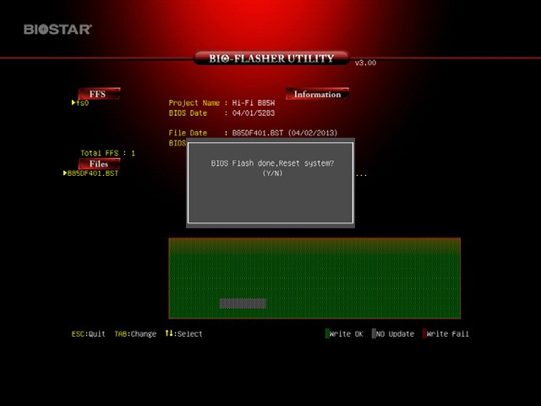
- A dialog pops out after BIOS flash is completed, asking you to restart the system. Press the <Y> key to restart system.
- While the system boots up and the full screen logo shows up, press <DEL> key to enter BIOS setup.
After entering the BIOS setup, please go to the <Save & Exit>, using the <Restore Defaults> function to load Optimized Defaults, and select <Save Changes and Reset> to restart the computer. Then the BIOS Update is completed.

BIOS Update Utility (through the Internet)
- Installing BIOS Update Utility from the DVD Driver.
- Please make sure the system is connected to the internet before using this function.
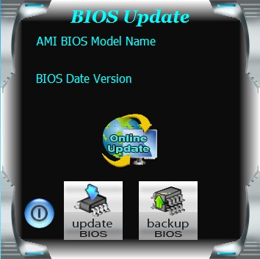
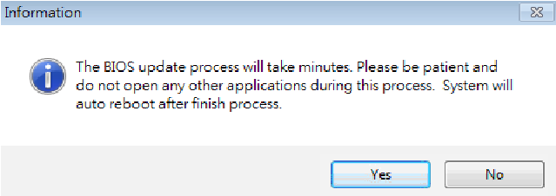
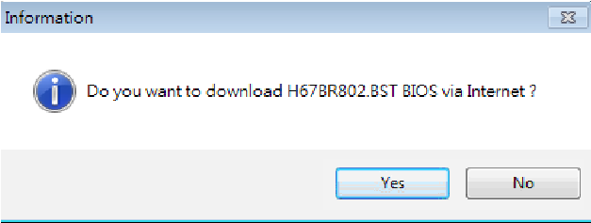
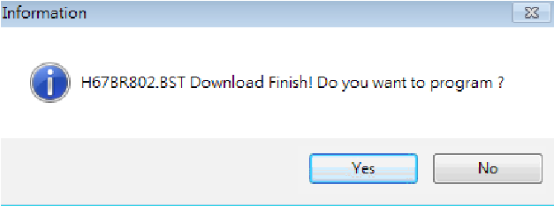
- Launch BIOS Update Utility and click the “Online Update” button on the main screen.
- An open dialog will show up to request your agreement to start the BIOS update. Click “Yes” to start the online update procedure.

- If there is a new BIOS version, the utility will ask you to download it. Click “Yes” to proceed.

- After the download is completed, you will be asked to program (update) the BIOS or not. Click “Yes” to proceed.

BIOS Update
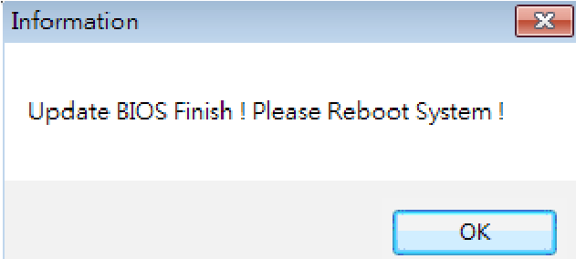
- After the updating process is finished, you will be asked you to reboot the system. Click “OK” to reboot.

- While the system boots up and the full screen logo shows up, press <DEL> key to enter BIOS setup.
After entering the BIOS setup, please go to the <Save & Exit>, using the <Restore Defaults> function to load Optimized Defaults, and select <Save Changes> and <Reset> to restart the computer. Then, the BIOS Update is completed.

BIOS Update Utility (through a BIOS file)
- Installing BIOS Update Utility from the DVD Driver.
- Download the proper BIOS from http://www.biostar.com.tw/
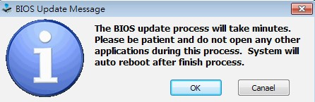
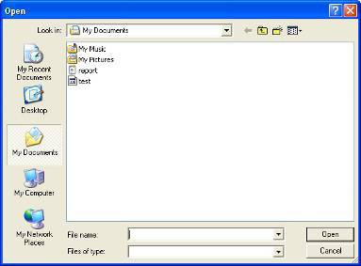
- Launch BIOS Update Utility and click the “Update BIOS” button on the main screen.
- A warning message will show up to request your agreement to start the BIOS update. Click “OK” to start the update procedure.
- Choose the location for your BIOS file in the system. Please select the proper BIOS file, and then click on “Open”. It will take several minutes, please be patient.
BIOS Update
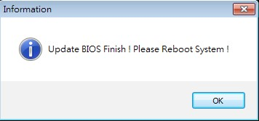
- After the BIOS Update process is finished, click on “OK” to reboot the system.
- While the system boots up and the full screen logo shows up, press <DEL> key to enter BIOS setup.
After entering the BIOS setup, please go to the <Save & Exit>, using the <Restore Defaults> function to load Optimized Defaults, and select <Save Changes and Reset> to restart the computer. Then, the BIOS Update is completed.

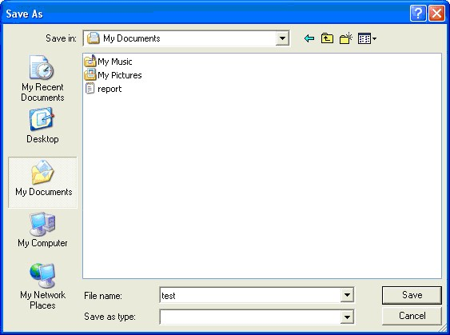
Backup BIOS
Click the Backup BIOS button on the main screen for the backup of BIOS, and select a proper location for your backup BIOS file in the system, and click “Save”.
UEFI BIOS Setup

UEFI BIOS Setup

Introduction
The purpose of this manual is to describe the settings in the AMI UEFI BIOS Setup program on this motherboard. The Setup program allows users to modify the basic system configuration and save these settings to NVRAM.
UEFI BIOS determines what a computer can do without accessing programs from a disk. This system controls most of the input and output devices such as keyboard, mouse, serial ports and disk drives. BIOS activates at the first stage of the booting process, loading and executing the operating system. Some additional features, such as virus and password protection or chipset fine-tuning options are also included in UEFI BIOS.
The rest of this manual will to guide you through the options and settings in UEFI BIOS Setup.
Plug and Play Support
This AMI UEFI BIOS supports the Plug and Play Version 1.0A specification.
EPA Green PC Support
This AMI UEFI BIOS supports Version 1.03 of the EPA Green PC specification.

ACPI Support
AMI ACPI UEFI BIOS support Version 1.0/2.0 of Advanced Configuration and Power interface specification (ACPI). It provides ASL code for power management and device configuration capabilities as defined in the ACPI specification, developed by Microsoft, Intel and Toshiba.

PCI Bus Support
This AMI UEFI BIOS also supports Version 2.3 of the Intel PCI (Peripheral Component Interconnect) local bus specification.
DRAM Support
DDR3 SDRAM (Double Data Rate III Synchronous DRAM) is supported.

Using Setup
When starting up the computer, press <Del> during the Power-On Self-Test (POST) to enter the UEFI BIOS setup utility.
In the UEFI BIOS setup utility, you will see General Help description at the top right corner, and this is providing a brief description of the selected item. Navigation Keys for that particular menu are at the bottom right corner, and you can use these keys to select item and change the settings.

Notice
» The default UEFI BIOS settings apply for most conditions to ensure optimum performance of the motherboard. If the system becomes unstable after changing any settings, please load the default settings to ensure system’s compatibility and stability. Use Load Setup Default under the Exit Menu.
» For better system performance, the UEFI BIOS firmware is being continuously updated. The UEFI BIOS information described in this manual is for your reference only. The actual UEFI BIOS information and settings on board may be slightly different from this manual.
» The content of this manual is subject to be changed without notice. We will not be responsible for any mistakes found in this user’s manual and any system damage that may be caused by wrong-settings.

UEFI BIOS Setup

1 Main Menu
Once you enter AMI UEFI BIOS Setup Utility, the Main Menu will appear on the screen providing an overview of the basic system information.
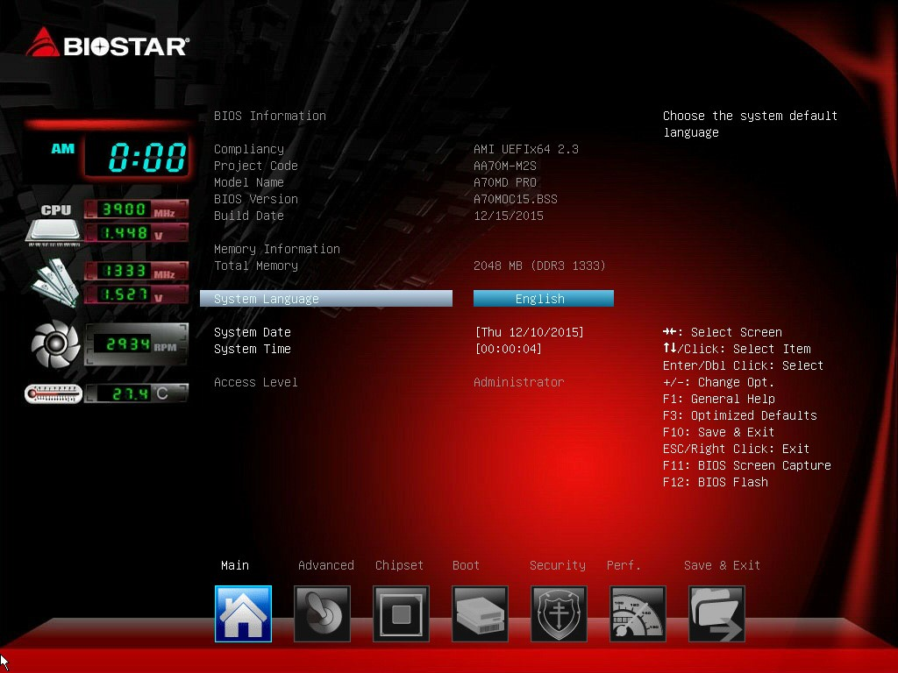

BIOS Information
It shows system information including UEFI BIOS version, Project Code, Model Name, Build Date and etc.
Total Memory
Shows system memory size, VGA shard memory will be excluded.
System Language
Choose the system default language.
System Date
Set the system date. Note that the ‘Day’ automatically changes when you set the date.

System Time
Set the system internal clock.
1 Main Menu

2 Advanced Menu
The Advanced Menu allows you to configure the settings of CPU, Super I/O, Power Management, and other system devices.

Notice
» Beware of that setting inappropriate values in items of this menu may cause system to malfunction.
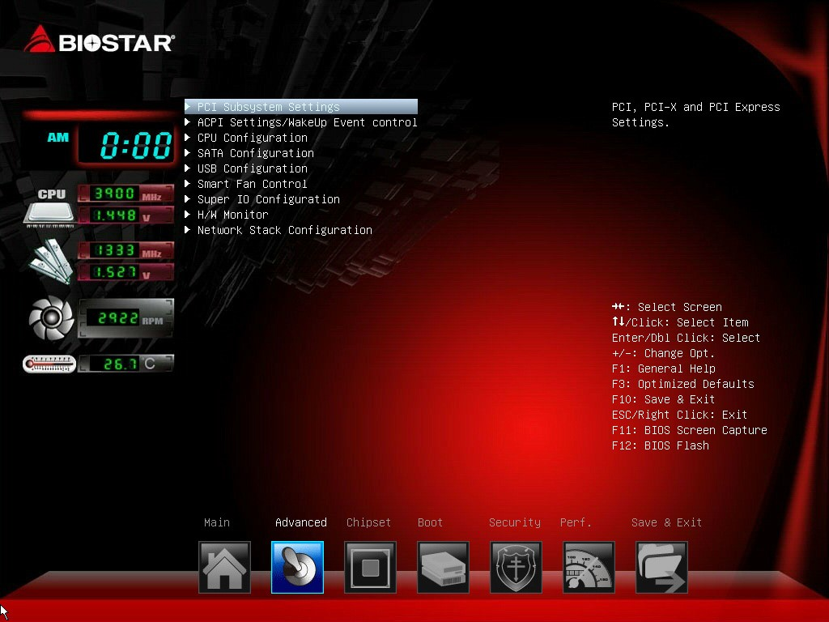

PCI Subsystem Settings
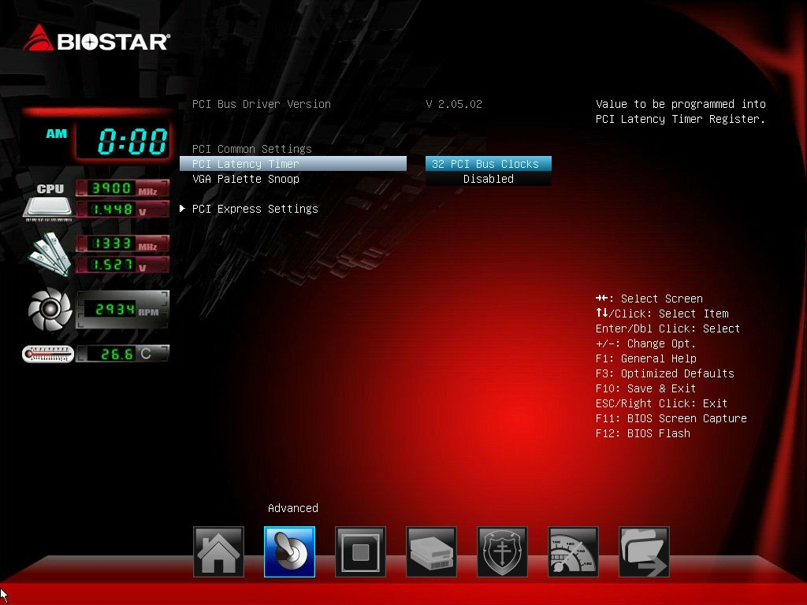

PCI Latency Timer
This item sets the value to be programmed into PCI Latency Timer Register.
Options: 32 PCI Bus Clocks (Default) / 64 PCI Bus Clocks / 96 PCI Bus Clocks / 128 PCI Bus Clocks / 160 PCI Bus Clocks / 192 PCI Bus Clocks / 224 PCI Bus Clocks / 248 PCI Bus Clocks
2 Advanced Menu

VGA Palette Snoop
This item enables or disables VGA Palette Registers Snooping. Options: Disabled (Default) / Enabled

PCI Express Settings
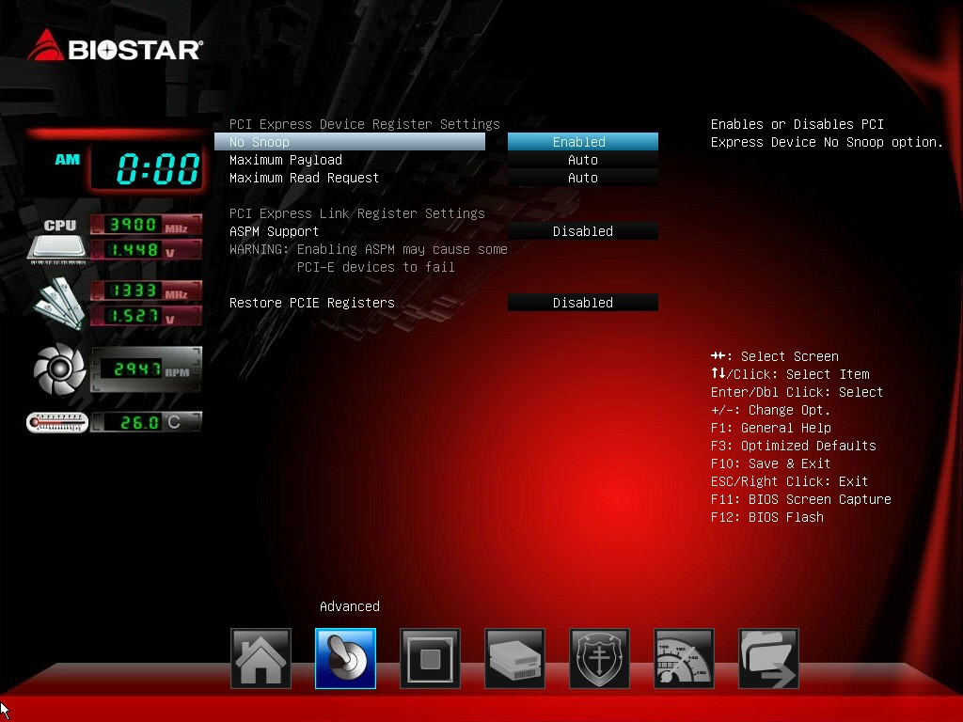

No Snoop
This item enables or disables PCI Express Device No Snoop option.
Options: Enabled (Default) / Disabled

Maximum Payload
This item sets Maximum Payload of PCI Express Device or allows System BIOS to select the value. Options: Auto (Default) / 128 Bytes / 256 Bytes / 512 Bytes / 1024 Bytes / 2048 Bytes / 4096 Bytes

Maximum Read Request
This item sets Maximum Read Request Size of PCI Express Device or allows System BIOS to select the value.
Options: Auto (Default) / 128 Bytes / 256 Bytes / 512 Bytes / 1024 Bytes / 2048 Bytes / 4096 Bytes ASPM Support
This item sets the ASPM Level: Force LO – Force all links to LO State; Auto – BIOS auto configures; Disabled – Disables ASPM.
Options: Disabled (Default) / Auto / Force L0s

Restore PCIE Registers
On non-PCI Express aware OS’s (Pre Windows Vista) some devices may not be correctly reinitialized after S3. Enabling this restores PCI Express device configurations on S3 resume. Warning: Enabling this cause issues with other hardware after resume.
Options: Disabled (Default) / Enabled
2 Advanced Menu

ACPI Settings/ WakeUp Event control
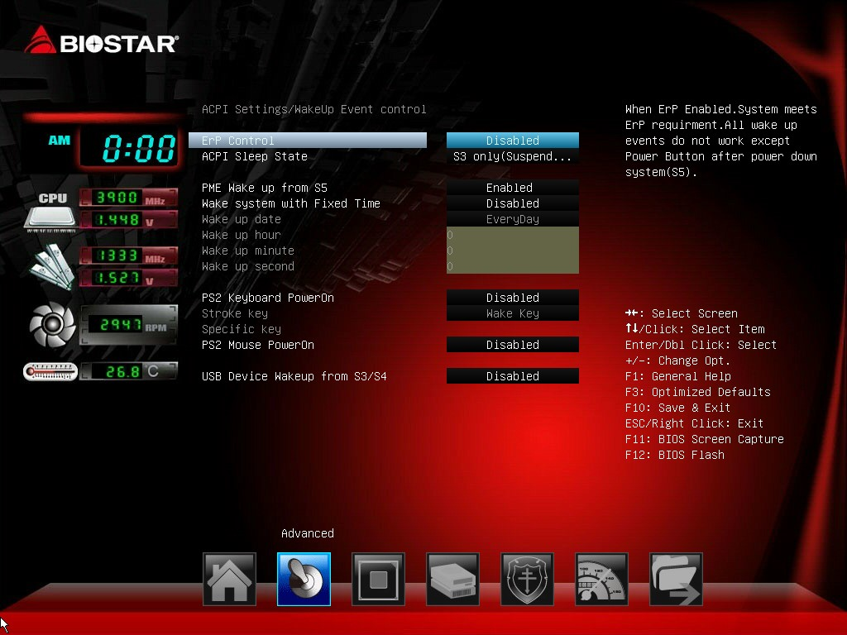

EuP Control
When EuP is enabled, the system will meet EuP requirement. All wake up events do not work except Power Button after power down system (S5).
Options: Disabled (Default) / Enabled

ACPI Sleep State
This item selects the highest ACPI sleep state the system will enter when the SUSPEND button is pressed.
Options: S3 only (Suspend to RAM) (Default) / Suspend Disabled

PME Wake up from S5
The item enables the system to wake from S5 using PME event.
Options: Disabled (Default) / Enabled

Wake system with Fixed Time
This item enables or disables the system to wake on by alarm event. When this item is enabled, the system will wake on the hr::min::sec specified.
Options: Disabled (Default) / Enabled

Wake up date
You can choose which date the system will boot up.
Wake up hour / Wake up minute / Wake up second
You can choose the system boot up time, input hour, minute and second to specify.

PS2 Keyboard PowerOn
This item allows you to control the keyboard power on function. Options: Disabled (Default) / Any Key / Stroke Key / Specific Key

Stroke Keys
This item will show only when Keyboard PowerOn is set “Stroke Key.”
Options: Wake Key (Default) / Power Key / Ctrl+F1 / Ctrl+F2 / Ctrl+F3 / Ctrl +F4 / Ctrl+F5 / Ctrl+F6

Specific Key
This item will show only when Keyboard PowerOn is set “Specific Key.” Press Enter to set Specific key.

PS2 Mouse PowerOn
This item allows you to control the mouse power on function.
Options: Disabled (Default) / Enabled

USB Device Wakeup from S3/S4
This item allows you to enable or disabled the USB resume from S3/S4 function. Options: Disabled (Default) / Enabled

CPU Configuration
This item shows CPU Information
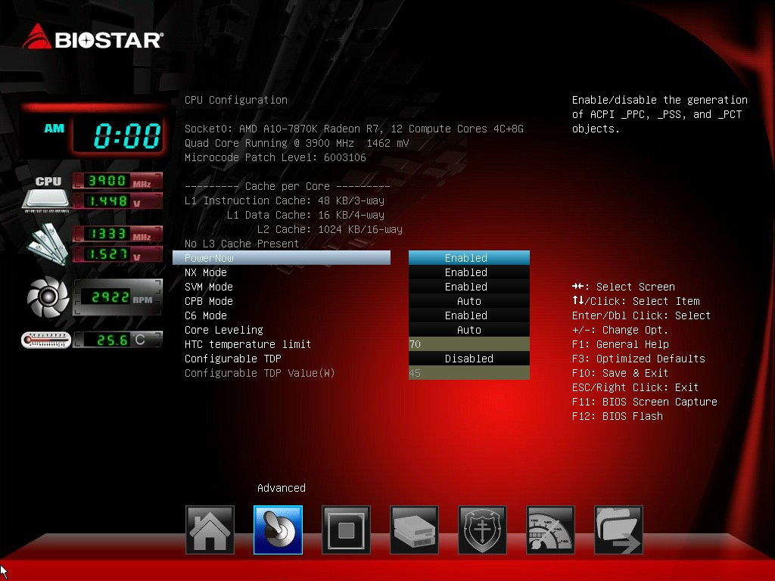

Power Now
This item allows you to enable or disable the PowerNow power saving technology. Options: Enabled (Default) / Disabled

NX Mode
This item allows you to enable or disable No-execute page protection Function Options: Enabled (Default) / Disabled

SVM
This item allows you to enable AMD virtualization in CPU.
Options: Enabled (Default) / Disabled

CPB Mode
This item allows you to enable or disable CPB.
Options: Auto (Default) / Disabled

C6 Mode
This item allows you to enable or disable C6.
Options: Enabled (Default) / Disabled

Core Leveling
Change the number of compute unit in the system
Options: Auto (Default) / Single Core / Dual Core

HTC temperature limit
This item allows you to set HTC temperature limit. Range: 70 °C - 85 °C Options: 70 °C(Default)

Configurable TDP (This item will appear only when using FM2+ CPU.)
This item allows you to enable or disable cTDP by CPU.
Options: Disabled (Default) / Enabled
» Note: The following items appear only when you set the Configurable TDP item to [Enabled] Configurable TDP Value (W)
This item allows you to input configurable TDP Value (45-65). Options: 45 (Default)

SATA Configuration
The BIOS will automatically detect the presence of SATA devices. There is a sub-menu for each SATA device. Select a device and press <Enter> to enter the sub-menu for detailed options.
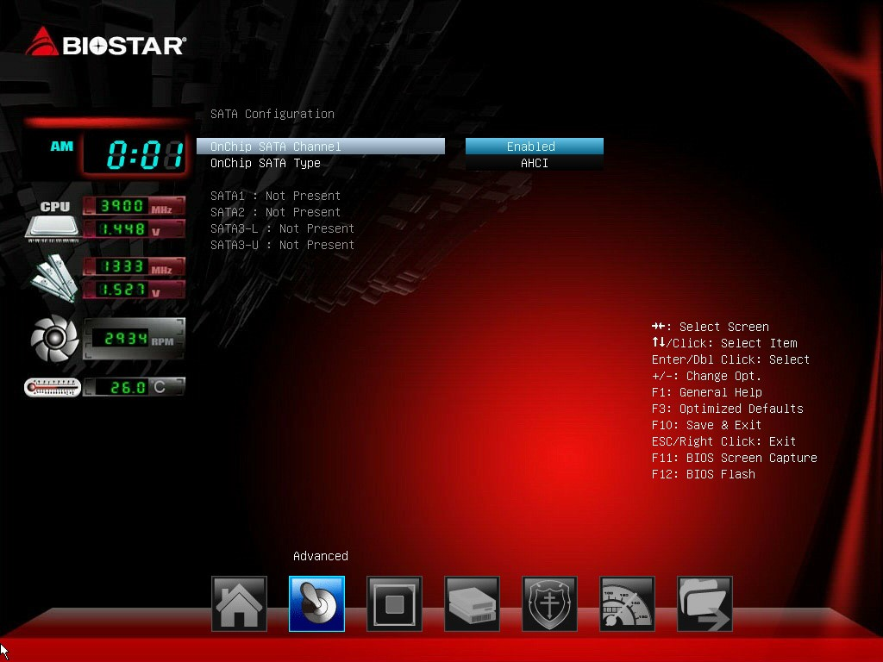

OnChip SATA Channel
This item allows you to enable or disable OnChip SATA Channel Options: Enabled (Default) / Disabled

OnChip SATA Type
This item allows you to set OnChip SATA type.
Options: Native IDE (Default) / RAID / AHCI / Legacy IDE

USB Configuration
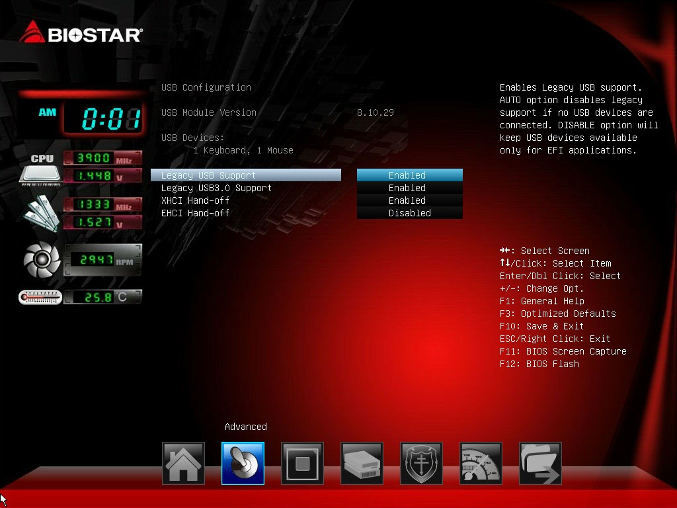

Legacy USB Support
The item allows you to enable Legacy USB support. AUTO option disables legacy support if no USB devices are connected. DISABLE option will keep USB devices available only for EFI applications. Options: Enabled (Default) / Disabled / Auto

Legacy USB3.0 Support
The item allows you to enable or disable Legacy USB3.0 (XHCI) Controller support. Options: Enabled (Default) / Disabled

XHCI Hand-Off
This is a workaround for OSes without XHCI hand-off support. The XHCI ownership change should be claimed by XHCI driver.
Options: Enabled (Default) / Disabled

EHCI Hand-Off
This is a workaround for OSes without EHCI hand-off support. The EHCI ownership change should be claimed by EHCI driver.
Options: Disabled (Default) / Enabled

Mass Storage Devices
Mass storage device emulation type. ‘Auto’ enumerates devices according to their media format. Optical drives are emulated as ‘CDROM’, drivers with no media will be emulated according to a driver type.
Options: Auto (Default) / Floppy / Forced FDD / Hard Disk / CR-ROM

Smart Fan Control
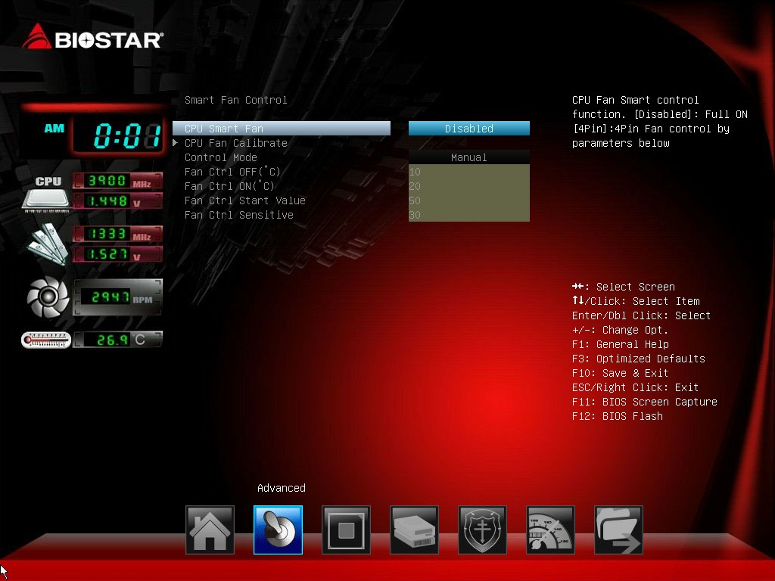

CPU Smart Fan
This item allows you to control the CPU Smart Fan function. Options: Disabled (Default) / 4Pin
CPU Fan Calibrate
Press [ENTER] to calibrate CPU Fan.

Control Mode
This item provides several operation modes of the fan.
Options: Quiet / Aggressive / Manual

Fan Ctrl OFF(°C)
When CPU temperature is lower than this value, the CPU fan will keep lowest RPM. Options: 10 (°C) (default)

Fan Ctrl On( °C)
When CPU temperature is higher than this value, the CPU fan controller will turn on. Options: 20 (°C) (Default)

Fan Ctrl Start Value
This item sets CPU FAN Start Speed Value.
Options: 50 (Default)

Fan Ctrl Sensitive
The bigger the numeral is, the higher the FAN speed is.
Options: 30 (Default)

Super IO Configuration
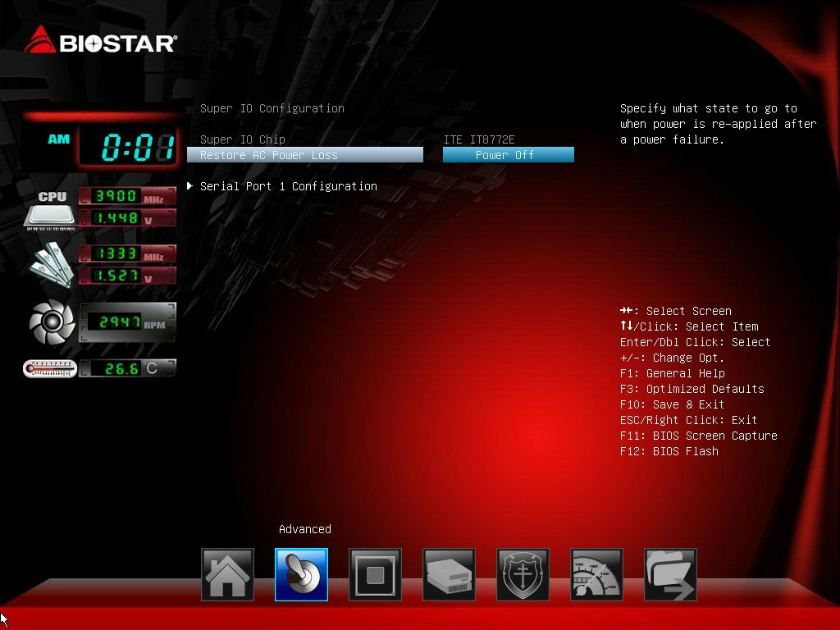

Restore AC Power Loss
This setting specifies how your system should behave after a power fail or interrupts occurs. Power Off: Leaving the system in power-off status after power recovers. Power ON: Powering on the system immediately when power returns. Last State: 1. Leaving the system in power-off if the system shuts down at DC off status; 2. Powering on the system immediately if the system shuts down at DC on status.
Options: Power Off (Default) / Power On / Last State

Serial Port 1 Configuration
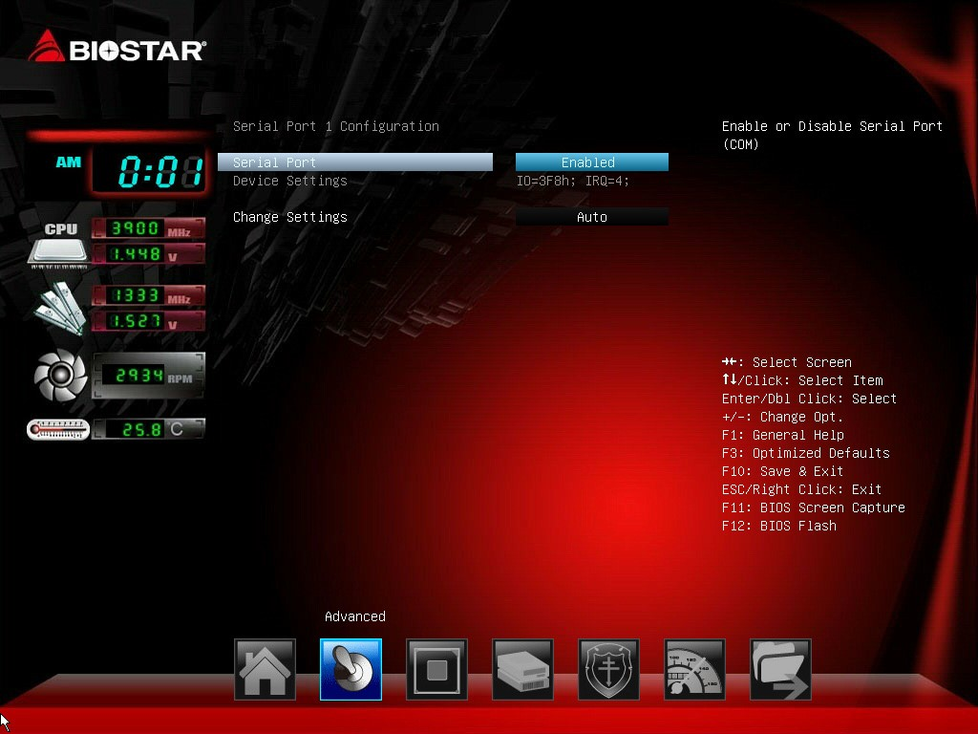

Serial Port
This item enables or disables Serial Port (COM). Options: Enabled (Default) / Disabled

Change Settings
This item selects an optimal setting for Super IO device.
Options: Auto (Default) / IO=3F8h; IRQ=4 / IO=3F8h; IRQ=3, 4, 5, 6, 7, 10, 11, 12 / IO=2F8h;
IRQ=3, 4, 5, 6, 7, 10, 11, 12 / IO=3E8h; IRQ=3, 4, 5, 6, 7, 10, 11, 12 / IO=2E8h; IRQ=3, 4, 5, 6, 7, 10, 11, 12

H/W Monitor
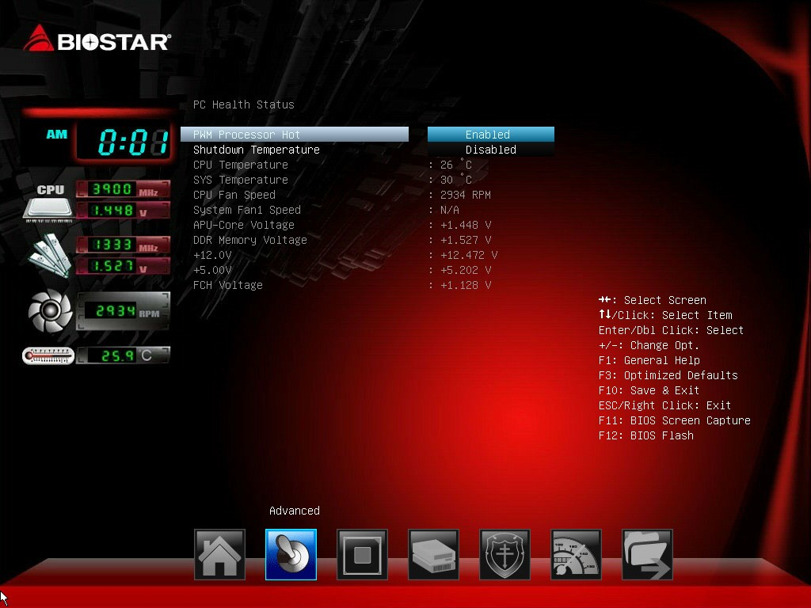

PWM Processor Hot
This item enables or disables PWM Processor Hot.
Options: Enabled (Default) / Disabled

Shutdown Temperature
This item allows you to set up the CPU shutdown Temperature.
Options: Disabled (Default) / 70°C/158°F / 75°C/167°F / 80°C/176°F

Network Stack
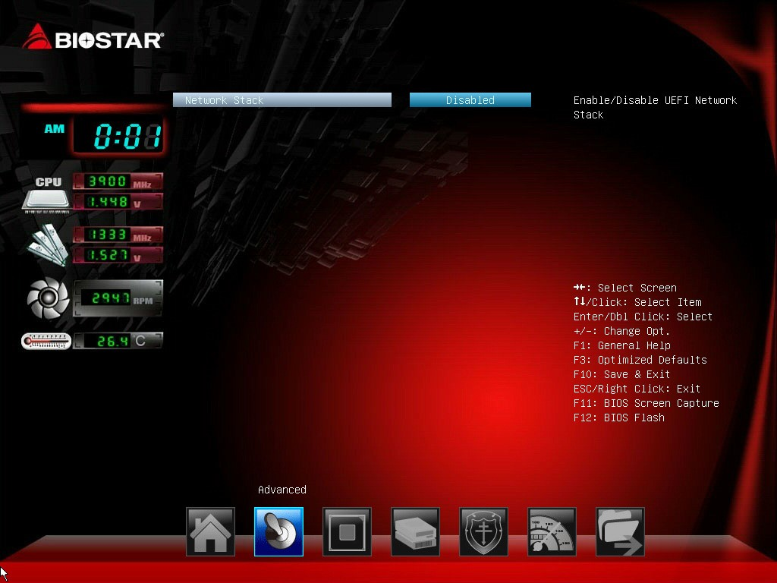

Network Stack
This item enables or disables UEFI network stack
Options: Disabled (Default) / Enabled
» Note: The following items appear only when you set the Network Stack item to [Enabled]

IPv4 PXE Support
This item enables or disables IPv4 PXE Boot Support. If disabled IPv4 booth option will not be created.
Options: Enabled (Default) / Disabled

IPv6 PXE Support
This item enables or disables IPv6 PXE Boot Support. If disabled IPv6 booth option will not be created.
Options: Enabled (Default) / Disabled
PXE boot wait time
Wait time to press ESC key to abort the PXE boot.
Media detect time
Wait time in sec to detect media.

3 Chipset Menu
This section describes configuring the PCI bus system. PCI, or Personal Computer Interconnect, is a system which allows I/O devices to operate at speeds nearing the speed of the CPU itself uses when communicating with its own special components.

» Notice: Beware of that setting inappropriate values in items of this menu may cause system to malfunction.
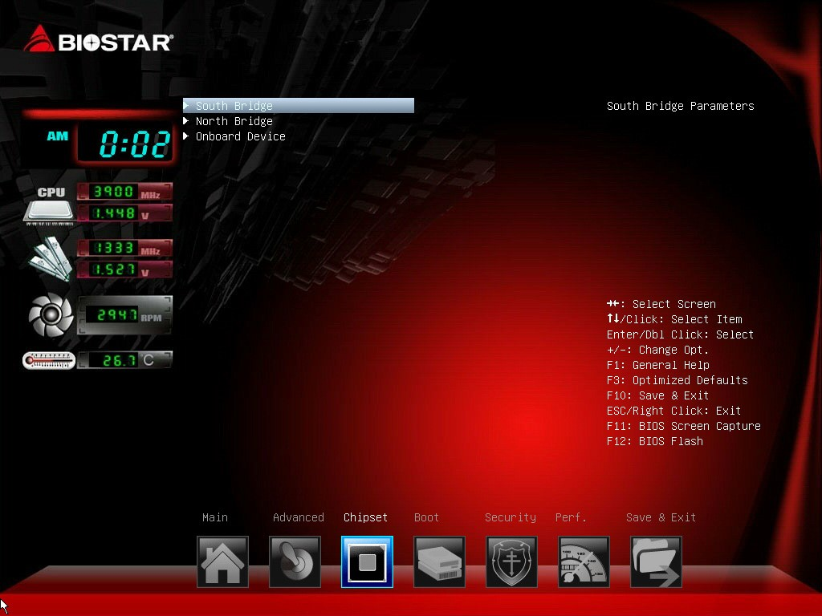

South Bridge
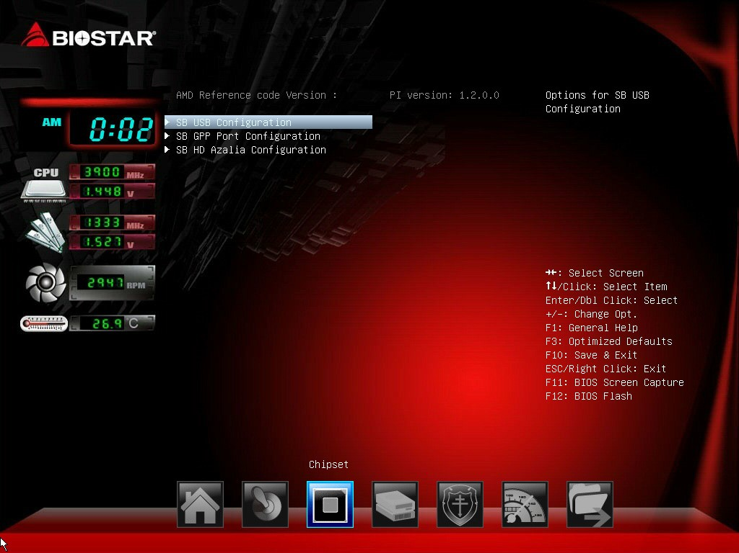

SB USB Configuration
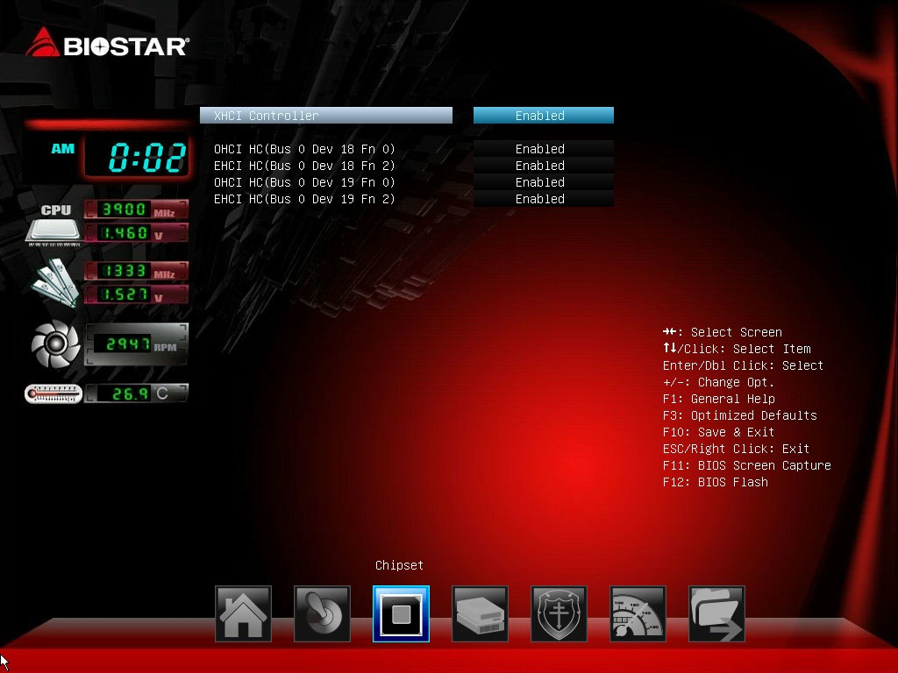

XHCI Controller
This item allows you to enable XHCI controller.
Options: Enabled (Default) / Disabled

OHCI HC (Bus 0 Dev 18/19 Fn 0)
This item allows you to control OHCI host controller. (USB 1.1 Device)
Options: Enabled (Default) / Disabled

EHCI HC (Bus 0 Dev 18/19 Fn 2)
This item allows you to control EHCI host controller. (USB 2.0 Device)
Options: Enabled (Default) / Disable
» Note: OHCI HC (Bus 0 Dev 22 Fn 0) and EHCI HC (Bus 0 Dev 22 Fn 2) items will appear, when you set the XHCI Controller item to disabled.

SB GPP Port Configuration
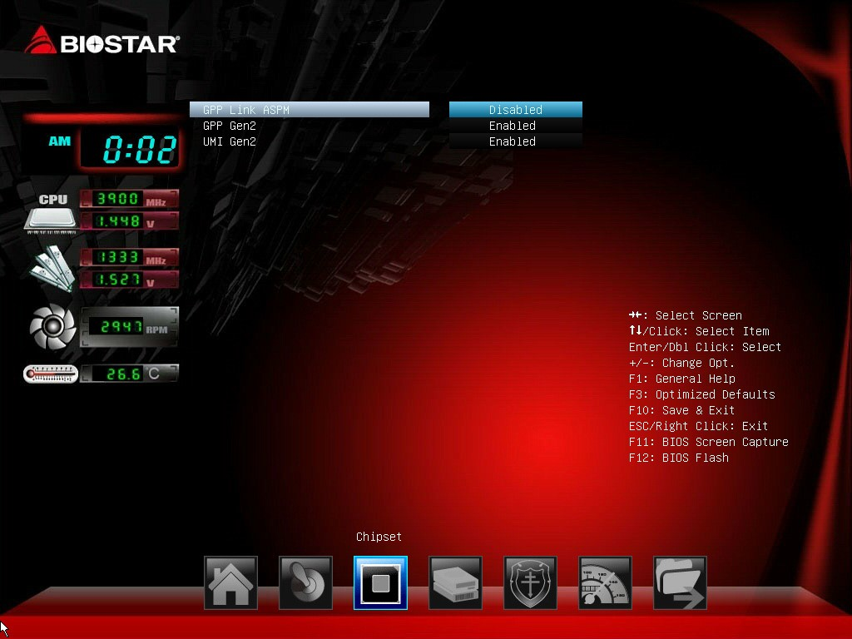

GPP Link ASPM
Options: Disabled (Default) / L0s / L1 / L0s + L1
GPP Gen2/ UMI Gen2
Options: Enabled (Default) / Disabled SB Azalia Audio Configuration
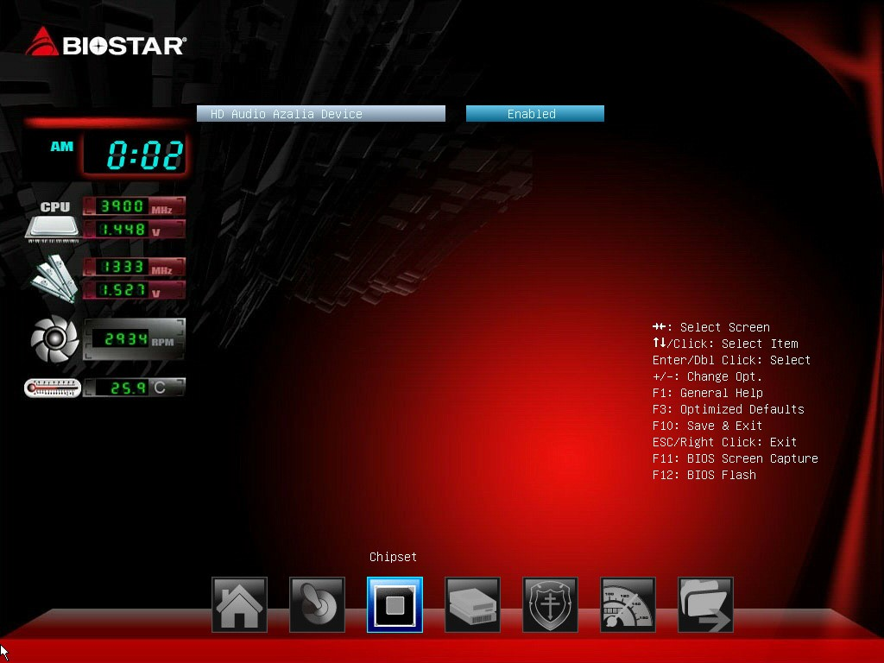

HD Audio Azalia Device
This item allows you to control the HD audio device.
Options: Enabled (Default) / Auto / Disabled

North Bridge
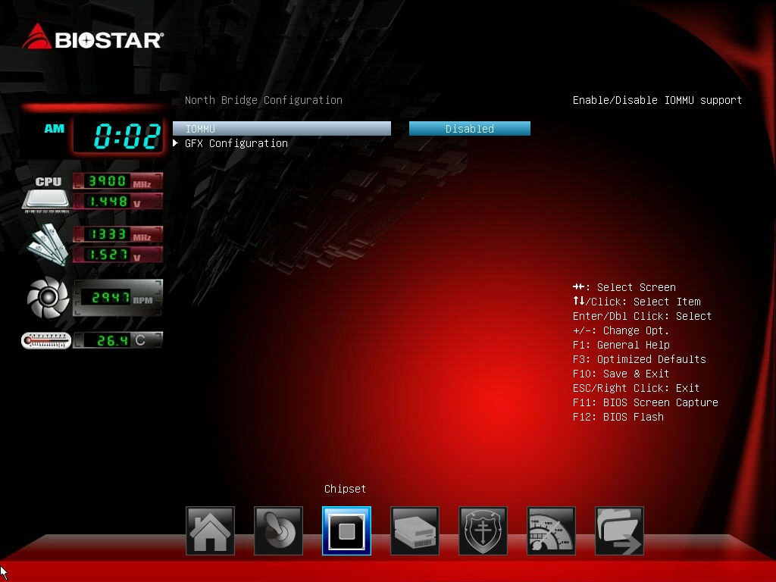

IOMMU
It enables or disables IOMMU support.
Options: Disabled (Default) / Enabled

GFX Configuration
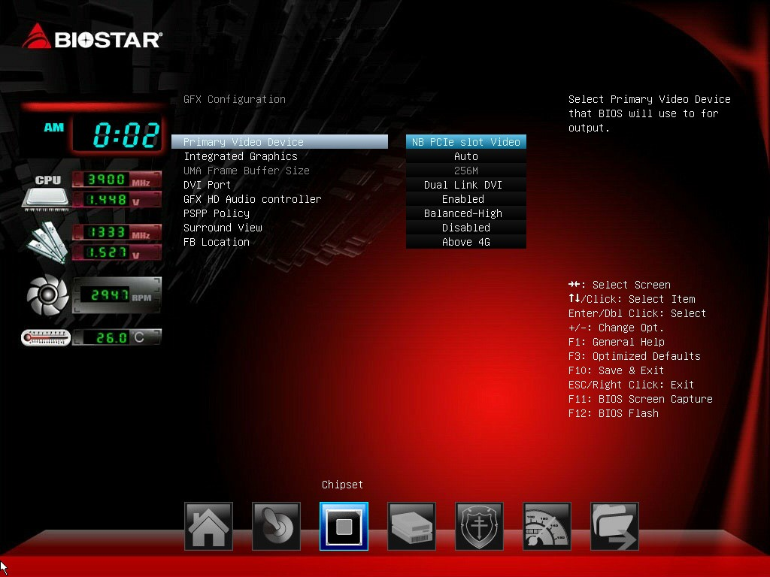

Primary Video Device
This item allows you to select Primary Video Device that BIOS will use to for output.
Options: NB PCIe slot Video (Default) / IGD Video

Integrated Graphics
This item set integrated graphics controller.
Options: Auto (Default) / Disabled / Force
» Note: The following items appear only when you set the Integrated Graphics item to [Force] UMA Frame Buffer Size: 32M / 64M / 128 M / 256 M / 512M / 1G / 2G

DVI Port
This item allows you to set DVI Port.
Options: Dual Link DVI (Default) / HDMI
» Note: The item is only for A70MD PRO/A68MD PRO.

GFX HD Audio Controller
This item allows you to set GFX HD Audio controller.
Options: Enabled (Default) / Disabled

PSPP Policy
This item allows you to set PCIe speed power policy.
Options: Balanced-High (Default) / Disabled / Performance / Balanced-Low / Power Saving

Surround View
This item supports multi-display function.
Options: Disabled (Default) / Enabled

FB Location
This item allows you to set FB Location
Options: Above 4G (Default) / Below 4G

Onboard Devices
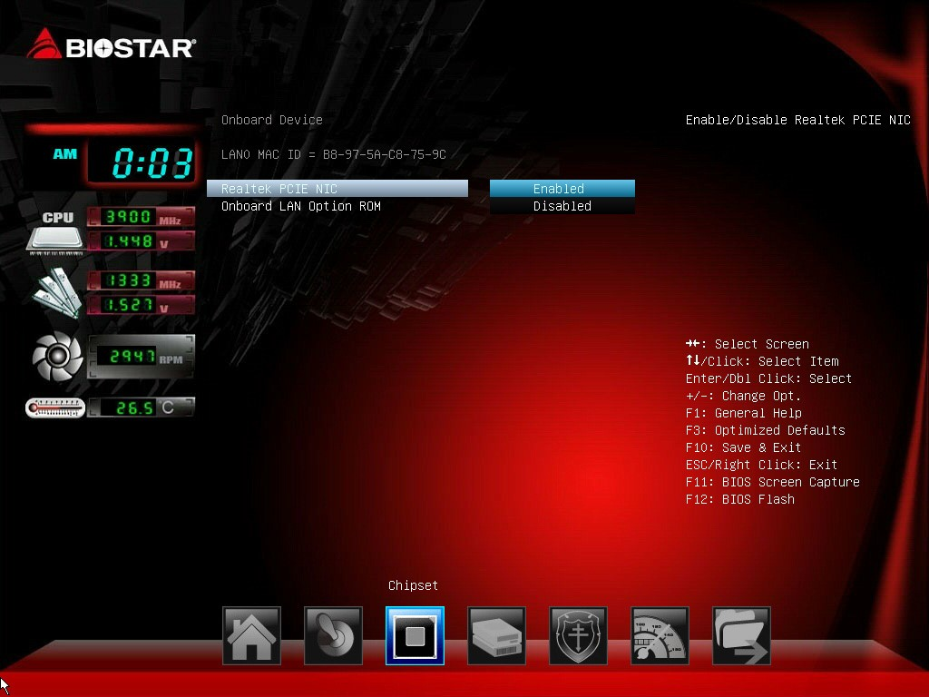

Realtek PCIE NIC
This item enables/disables Realtek PCIE NIC
Options: Enabled (Default) / Disabled

Onboard LAN Option ROM
This item enables/disables Onboard LAN Option ROM
Options: Disabled (Default) / Enabled

4 Boot Menu
This menu allows you to setup the system boot options.
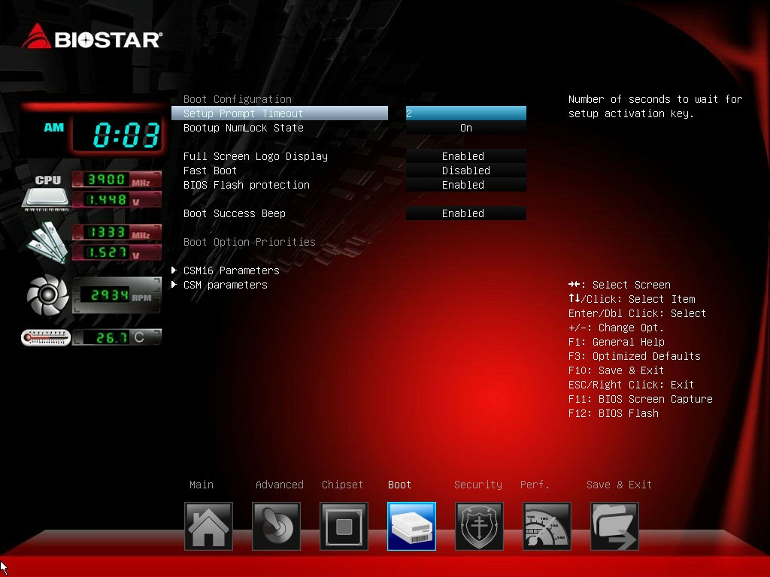

Setup Prompt Timeout
This item sets number of seconds to wait for setup activation key. Options: 2 (Default)

Bootup NumLock State
This item selects the keyboard NumLock state. Options: On (Default) / Off

Full Screen Logo Display
This item allows you to enable/disable Full Screen Logo Show function. Options: Enabled (Default) / Disabled

Fast Boot
This item allows you to enable/disable boot with initialization of a minimal set of devices required to launch active boot option. Has no effect for BBS boot options.
Options: Disabled (Default) / Enabled
» Note: The following items appear only when you set the Fast Boot function to [Enabled]
SATA Support
Options: Last Boot HDD Only (Default) / All SATA Devices

VGA Support
If Auto, only install Legacy OpRom with Legacy OS and logo would NOT be shown during post. EFI driver will still installed with EFI. Options: EFI Driver (Default) / Auto
4 Boot Menu

USB Support
If Disabled, all USB devices will NOT be available until after OS boot. If Partial Initial, specific USB port/device will NOT be available before OS boot. If Enabled, all USB devices will be available in OS and Post.
Options: Full Initial (Default) / Partial Initial / Disabled

PS2 Devices Support
If Disabled, PS2 devices will be skipped.
Options: Enabled (Default) / Disabled

Network Stack Driver Support
If Disabled, Network Stack Drivers will be skipped.
Options: Disabled (Default) / Enabled

BIOS Flash protection
While enabled, it can’t flash write and flash erase by SMI. Options: Enabled (Default) / Disabled

Boot Success Beep
When this item is set to Enabled, BIOS will let user know boot success with beep. Options: Enabled (Default) / Disabled

Boot Option #1/#2/#3
The items specify the boot device priority sequence from the available devices. The number of device items that appears on the screen depends on the number of devices installed in the system.
CD/DVD ROM Drive BBS Priorities
This item sets the order of the legacy devices in this group.

Hard Drive BBS Priorities
This item sets the order of the legacy devices in this group.
4 Boot Menu

CSM16 parameters
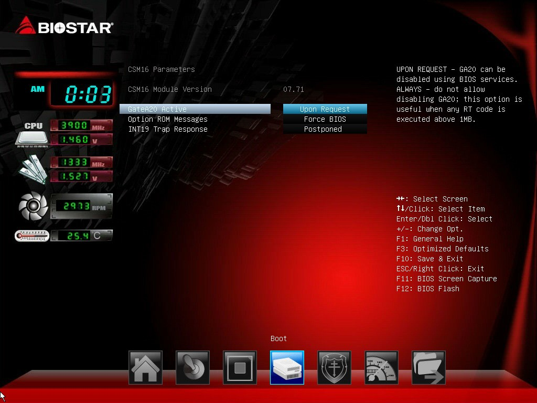

GateA20 Active
Upon Request – FA20 can be disabled using BIOS services. Always – do not allow disabling GA20; this option is useful when any RT code is executed above 1MB Options: Upon Request (Default) / Always

Option ROM Messages
This item sets the display mode for option ROM.
Options: Force BIOS (Default) / Keep Current

INT19 Trap Response
BIOS reaction on INT19 trapping by Option ROM: IMMEDIATE – execute the trap right away; POSTPONED – execute the trap during legacy boot.
Options: Postponed (Default) / Immediate
4 Boot Menu

CSM parameters
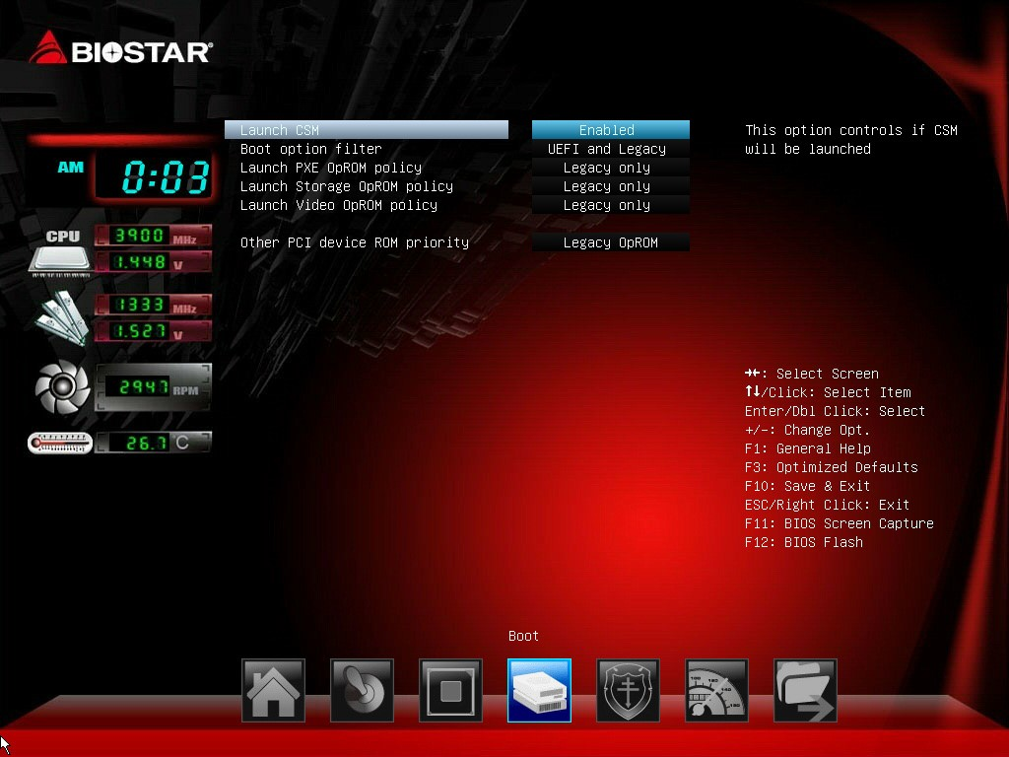

Launch CSM
This option controls if CSM will be launched.
Options: Enabled (Default) / Disabled

Boot option filter
This option controls what devices system can boot to.
Options: UEFI and Legacy (Default) / Legacy only / UEFI only

Launch PXE OpROM policy
This item controls the execution of UEFI and Legacy PXE OpROM
Options: Legacy only (Default) / UEFI only / Do not launch

Launch Storage OpROM policy
This item controls the execution of UEFI and Legacy Storage OpROM
Options: Legacy only (Default) / UEFI only / Do not launch

Launch Video OpROM policy
This item controls the execution of UEFI and Legacy Video OpROM
Options: Legacy only (Default) / UEFI only / Do not launch

Other PCI device ROM priority
For PCI devices other than Network, Mass storage or Video defines which OpROM to launch Options: Legacy OpROM (Default) / UEFI OpROM

5 Security Menu

5 Security Menu
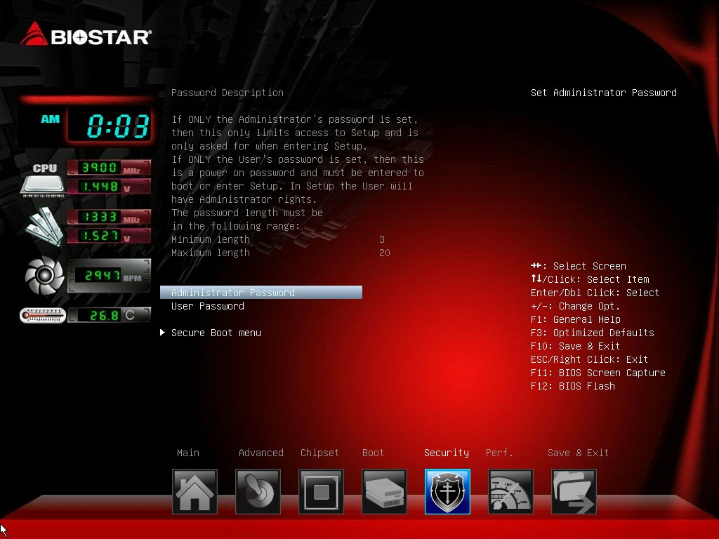
Administrator Password
This item sets Administrator Password.
User Password
This item sets User Password.

Secure Boot Menu
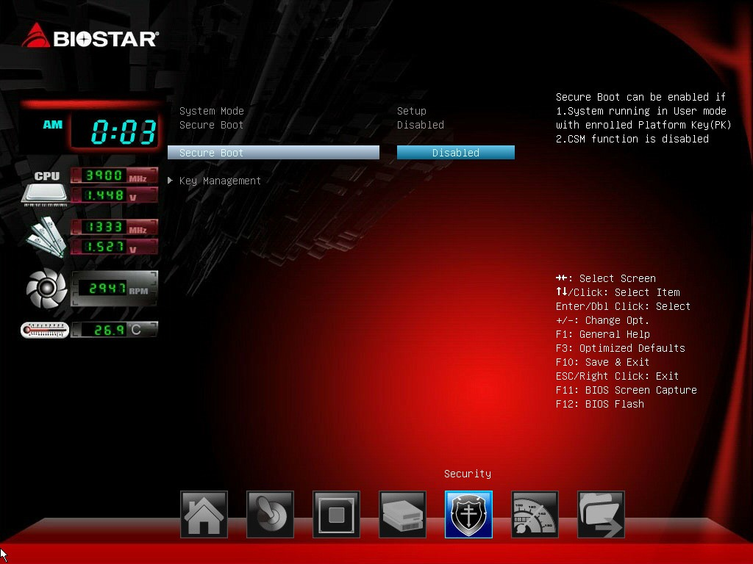
5 Security Menu

Secure Boot Control
Secure Boot flow control. Secure Boot can be enabled only when 1. Platform Key (PK) is enrolled and Platform is operating in user mode and 2.CSM function is disabled in Setup.
Options: Disabled (Default) / Enabled
Note: The following items appear only when you set the Secure Boot Control function to [Enabled]

Key Management
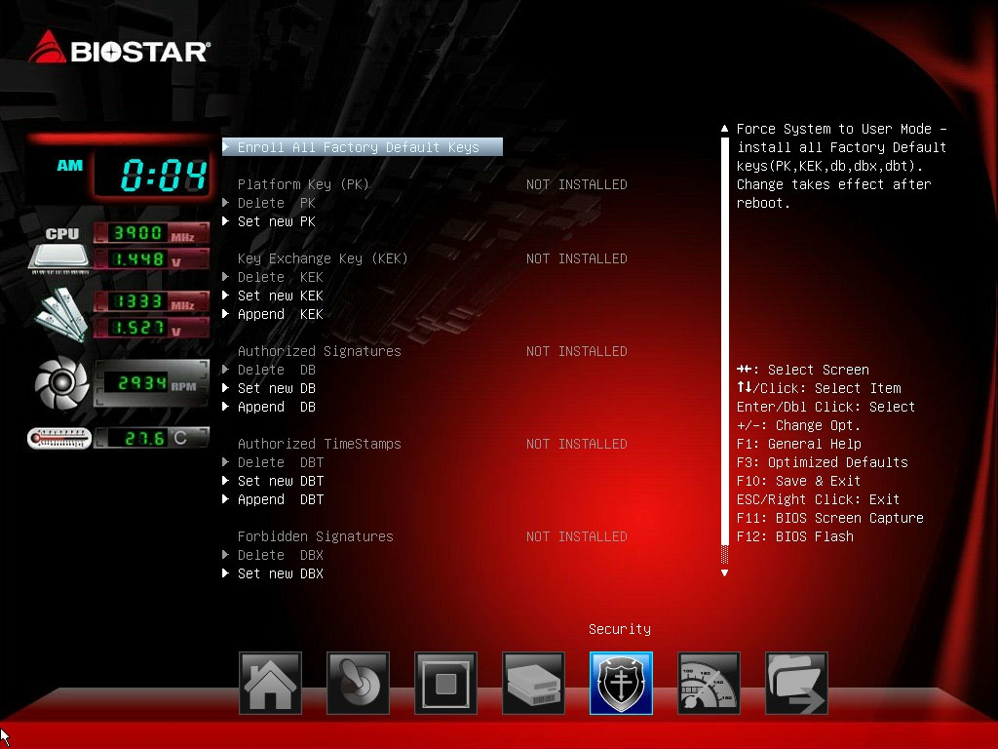

Enroll All Factory Default Keys
It allows you to immediately load/clear the default Security Boot keys, Platform key (PK), Keyexchange Key (KEK), Signature database (db), and Revoked Signatures (dbx). The Platform Key (PK) state will change from Unloaded mode to Loaded mode. The settings are applied after reboot or at the next reboot.

Platform Key (PK)
Delete PK – Allows you to delete the PK file from your system. Set new PK – Allows you set new PK file.

Key Exchange Key Database (KEK)
Delete KEK – Allows you to delete the KEK file from your system.
Set new KEK – Allows you set new KEK file.
Append Var to KEK – Allows you append Var to KEK.

Authorized Signature Database (DB)
Delete DB – Allows you to delete the DB file from your system.
Set new DB – Allows you set new DB file.
Append Var to DB – Allows you append Var to DB.

Authorized Timestamps Database (DBT)
Delete DBT – Allows you to delete the DBT file from your system.
Set new DBT – Allows you set new DBT file.
Append Var to DBT – Allows you append Var to DBT.

Forbidden Signature Database (DBX)
Delete DBX – Allows you to delete the DBX file from your system.
Set new DBX – Allows you set new DBK file.
Append Var to DBX – Allows you append Var to DBX.
5 Security Menu

6 Performance Menu
This submenu allows you to change voltage and clock of various devices.
(However, we suggest you use the default setting. Changing the voltage and clock improperly may damage the device.)

Notice
» The options and default settings might be different by RAM or CPU models.
» Beware of that setting inappropriate values in items of this menu may cause system to malfunction.
- Values in Red: Danger
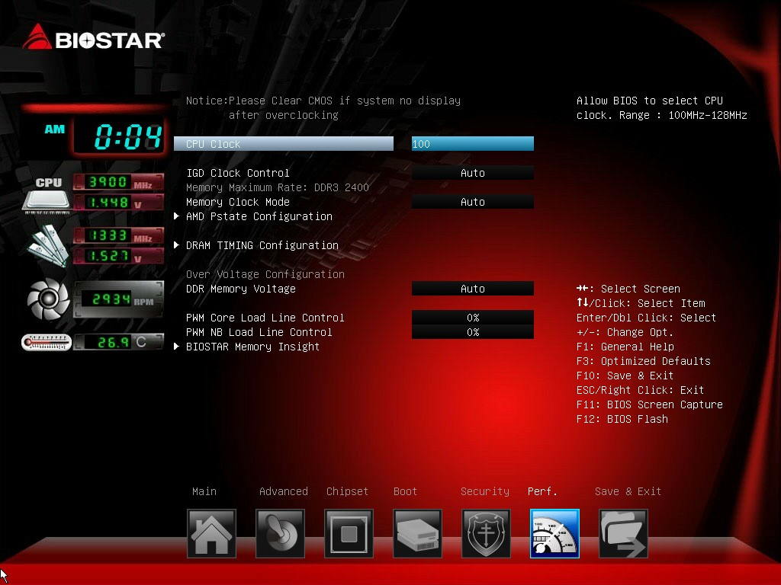
-
Values in Yellow: Warning
-
Values in White: Normal

CPU Clock
This item allows user to adjust CPU clock
Range: 100MHz-128Mhz

IGD Clock Control
This item allows user to adjust IGD clock
Options: Auto (Default) / Enabled
» Note: The following items appear only when you set the IGD Clock Control item to [Enabled]
IGD Clock
Allow BIOS to Select IGD clock, Range 300MHz-2000MHz

Memory Clock Mode
This item allows user to select the DRAM Frequency programming method. If Auto, the DRAM speed will be based on SPDs. If Manual, the DRAM speed specified will be programmed regardless of SPD. If AMP/XMP/XMP2, the DRAM speed specified will be refer memory profile.
Options: Auto (Default) / Manual / AMP / XMP1 / XMP2
» Note: The following items appear only when you set the Memory Clock Mode item to [Manual]
Memory Frequency: DDR 800 / DDR3 1066 / DDR3 1333 / DDR3 1600 / DDR3 1866 / DDR3 2133 / DDR3 2400
6 Performance Menu

AMD Pstate Configuration
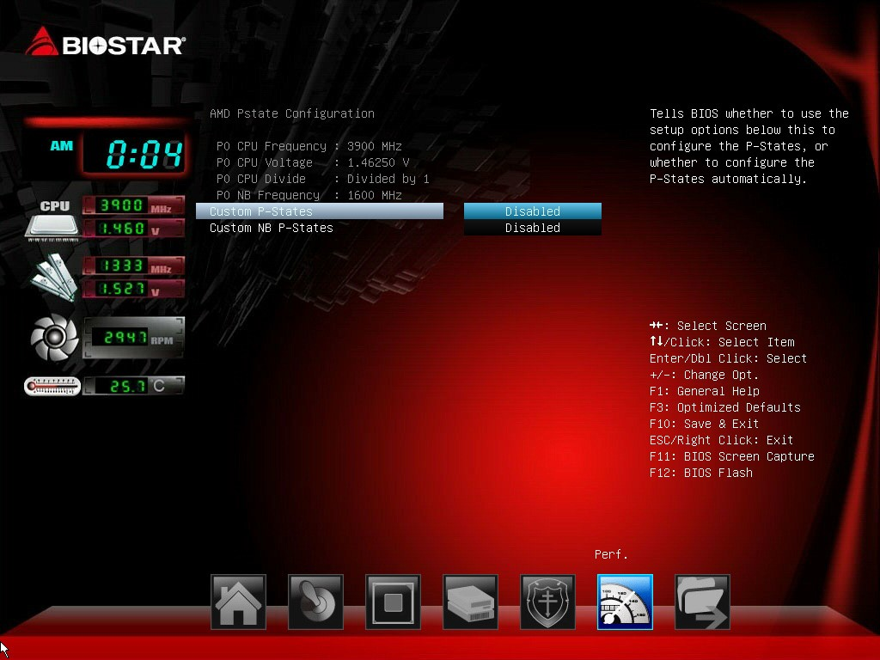

Custom P-Stated
This item will tell BIOS whether to use the step option below this configure the P-State, or whether to configure the P-States automatically.
Options: Disabled (Default) / Enabled
» Note: The following items appear only when you set the Custom P-State item to [Enabled]

Core FID
This item sets the frequency to use for Core P-State selected. Value is saved in the _PSS object. Options: x16 1600MHz ~ x63 6300MHz
Core VID
This function allows you to adjust the voltage of Core.

Core DID
This is the Core Divider.
Options: Divided by 1 (Default) / Divided by 2 / Divided by 4 / Divided by 8 / Divided by 16 Custom NB P-Stated
The item tells BIOS whether to use the setup options below this to configure the NB P-States, or whether to configure the NB P-states automatically.
Options: Disabled (Default) / Enabled
» Note: The following items appear only when you set the Custom NB P-State item to [Enabled]

NB FID
This item sets the frequency to use for Core P-State selected. Value is saved in the _PSS object.
Options: 400MHz ~ 1600MHz
6 Performance Menu

DRAM Timing Configuration
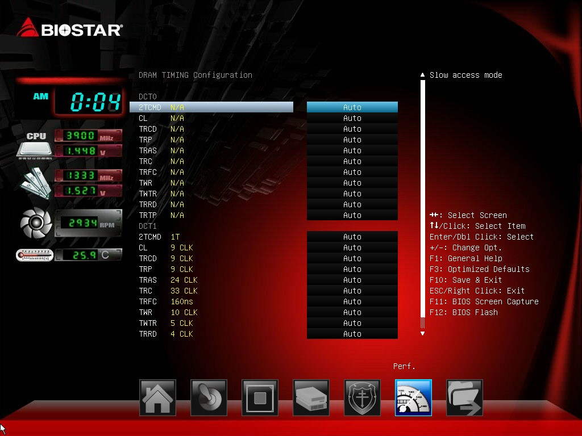
2TCMD
Options: Auto (Default) / 1T / 2T
CL
Options: Auto (Default) / 5~16 CLK
TRCD
Options: Auto (Default) / 2~19 CLK
TRP
Options: Auto (Default) / 5~19 CLK
TRAS
Options: Auto (Default) / 8~42 CLK
TRC
Options: Auto (Default) / 10~58 CLK
TRFC
Options: Auto (Default) / 90ns / 110ns / 160ns / 300ns / 350ns
TWR
Options: Auto (Default) / 5~8 / 10 / 12 / 14 / 16 CLK
TWTR
Options: Auto (Default) / 4~11 CLK
TRRD
Options: Auto (Default) / 1~9 CLK
TRTP
Options: Auto (Default) / 4~11 CLK
DDR Memory Voltage
This item allows you to select DDR Memory Voltage Control.

PWM Core Load Line Control
This item allows you to set PWM Core Load Line Control
Options: 0% (Default) / Disabled / -40% / -20% / +20% / +40% / +60% / +80%
6 Performance Menu

PWM NB Load Line Control
This item allows you to set PWM NB Load Line Control
Options: 0% (Default) / Disabled / -40% / -20% / +20% / +40% / +60% / +80%

BIOSTAR Memory Insight
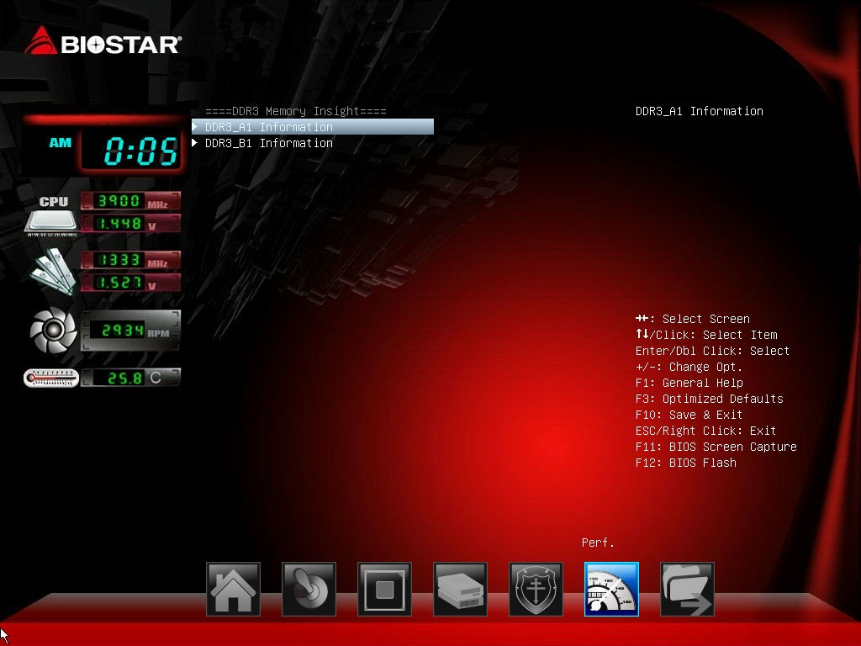

DDR3_A1/B1
These items display SPD information of DDR3 memory.
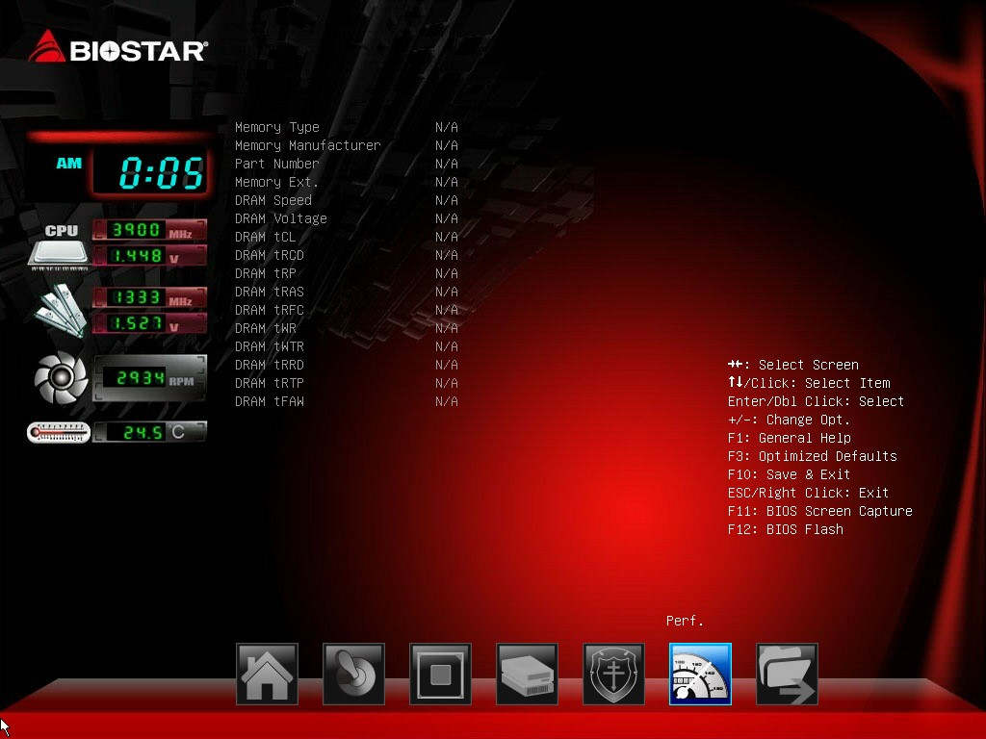
6 Performance Menu

7 Exit Menu
This menu allows you to load the optimal default settings, and save or discard the changes to the BIOS items.
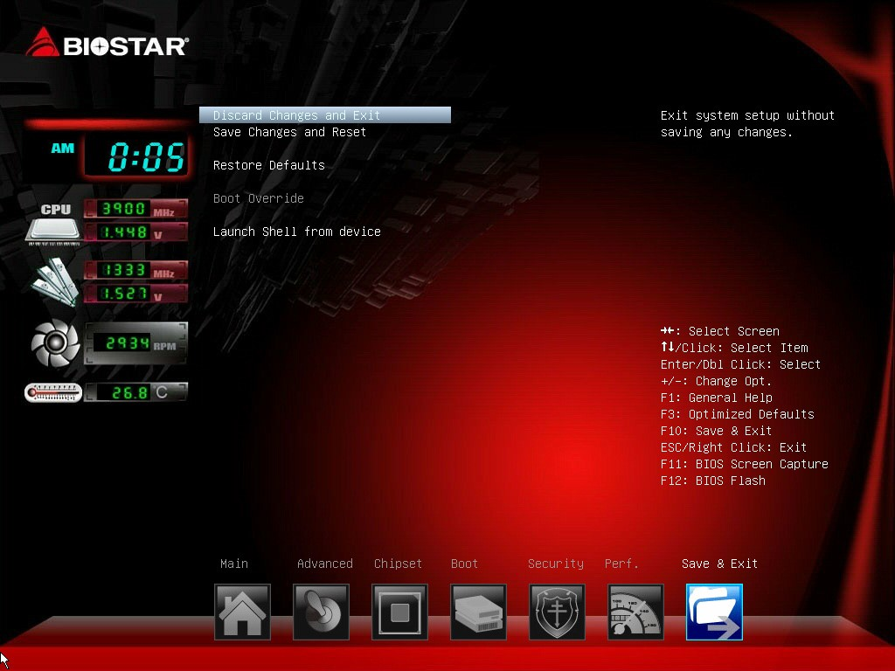
Discard Changes and Exit
Abandon all changes made during the current session and exit setup.
Save Changes and Reset
Reset the system after saving the changes.

Restore Defaults
This selection allows you to reload the BIOS when problem occurs during system booting sequence. These configurations are factory settings optimized for this system.

Launch Shell from device
This item attempts to EFI Shell application (Shellx64.efi) from one of the available devices.
7 Exit Menu

