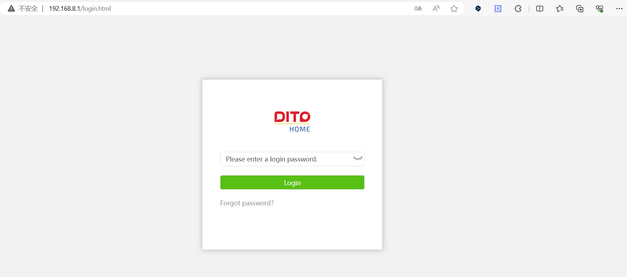
Please go to the router background through telnet 192.168.8.1
Login：root
Password: Fireitup
Enter command : cat /tmp/hw_config
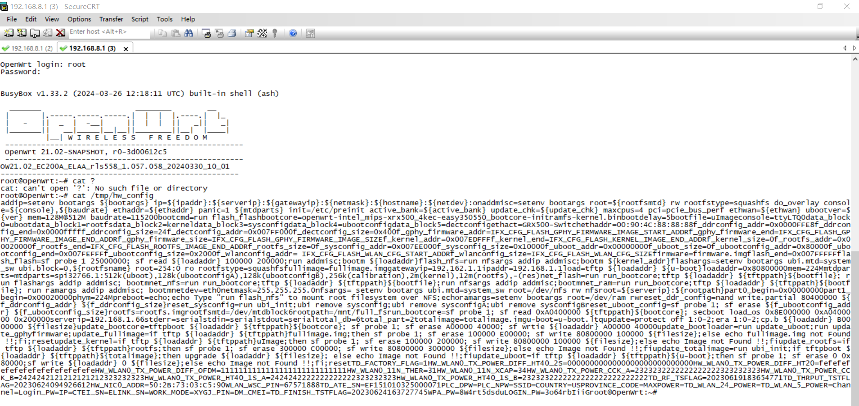
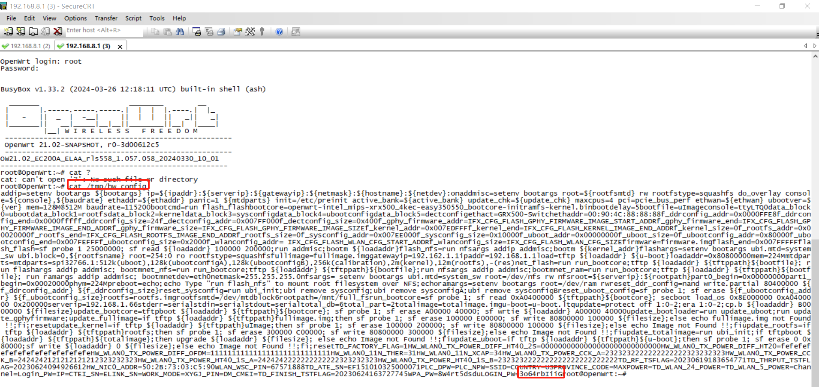
There is at the end: LOGIN PW=
The next ten characters are the initial password
Log in to the web page 192.168.8.1
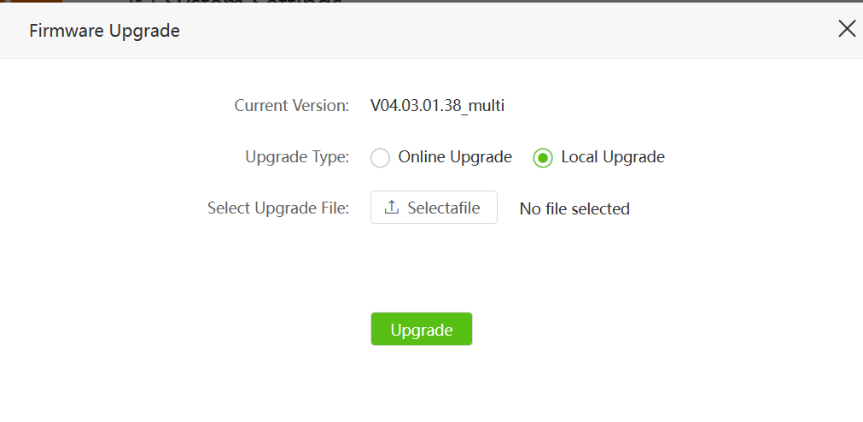
Local upgrade
Upgraded back to V04.03.01.37 multi


