Firmware update SOP
- Download the folder “SSD Dash-v6.0.12” ;
- Open the folder and click the application “SSD Dash” to go on;
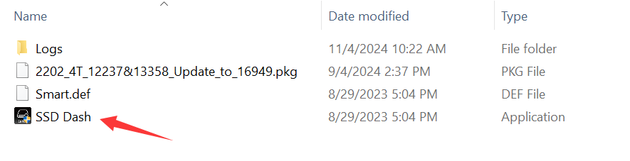
- Click “About US” > select the drive > click “Select” > click the package > Open > Update


