Dual OS Flash Guide

Attention matters:
1. Before the system installation, please read below tips carefully;
2. This installation is fit for the situation when the BIOS is not damaged and update the system.
3. All data will be cleared when install the system, so please backup important data in advance.
4. The installation process takes about 30-40 minutes, before installation please ensure that the tablet is with sufficient electricity.
5. The flash have Android flash and Windows flash 2 kinds. you can choose one separately according to your demand.

Preparation works:
1, download the corresponding firmware packages and unzip it via WINRAR tool;
2, a U disk over 8GB;
3, a USB HUB with external power supplying;
4, a keyboard with USB interface;
Note: if you only flash Android firmware, no need to prepare 2, 3, 4 points mentioned tools;

Operation steps:
一、Flash Android os
1, open "Android flash tools" folder, install below programs as order:
1) iSocUSB-Driver-Setup-1.2.0.exe
2) IntelAndroidDrvSetup1.5.0.exe
3) PhoneFlashTool_5.3.2.0_win32.exe

Special attention:
a, install the flash tools as above order.
b, keep the default installation settings and path in process.
c, after the successful installation, flash tool shortcut will appear on computer desktop, as pic. 1:
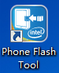 pic. 1
d, please operate as above steps, otherwise it will cause flash failure.

2, flashing android os via update mode won’t remove windows os. (it won’t clear android settings and files, just like OTA update. )

2.1 run "Phone Flash Tool" , click “Browser”button, in pop-up window load the android burning file :
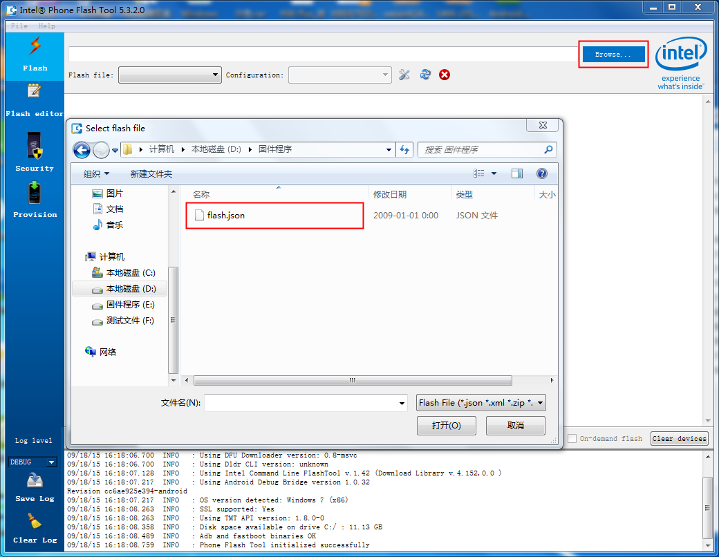

2.2 then rewrite “Configuration” content as “update”, as below:
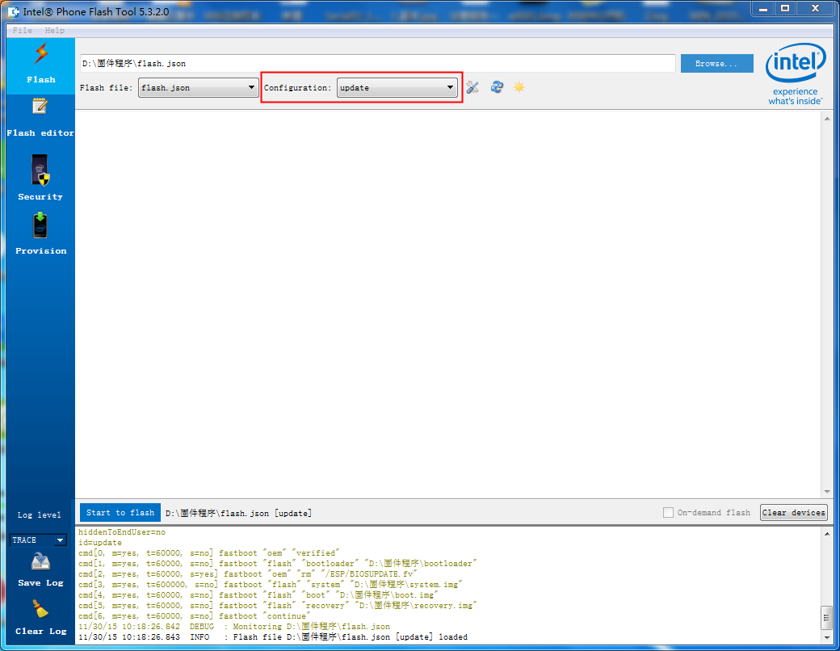

2.3 reboot tablet and enter android os, open “Settings” APK---- “Developer options”, open “USB debugging” item, as below:
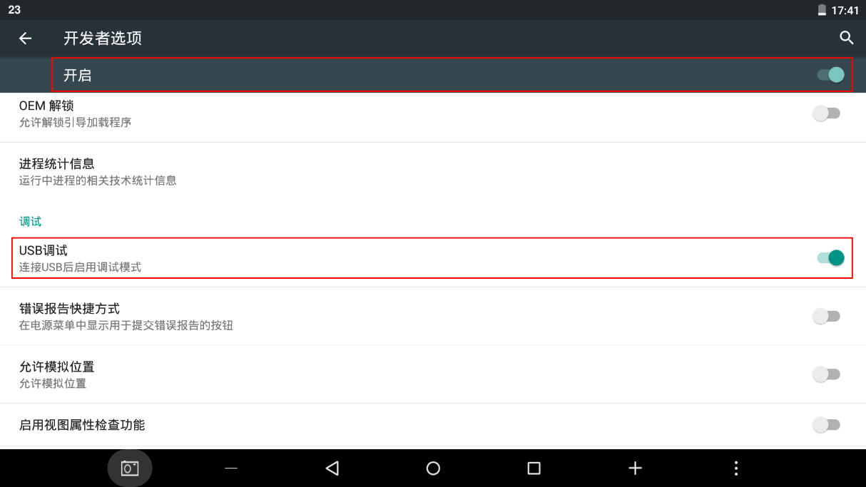

2.4 connect tablet with computer via USB cable, after computer recognizing the device driver, flash tool will appear “Start to Flash” button, it means that tablet connects with computer successfully, as below:
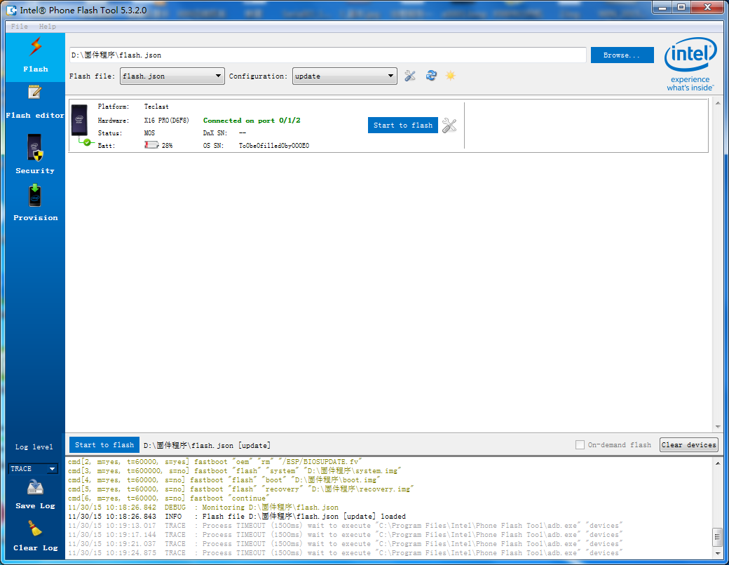

2.5 click “Start to Flash” button, it starts to burn android firmware.
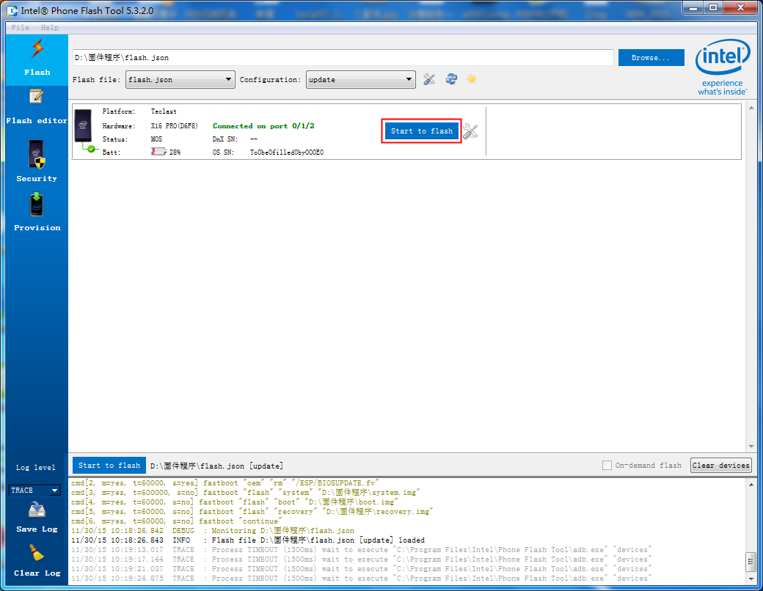

2.6 the process is as below, it will take long time, just wait patiently. Don’t do other unnecessary operations in process. 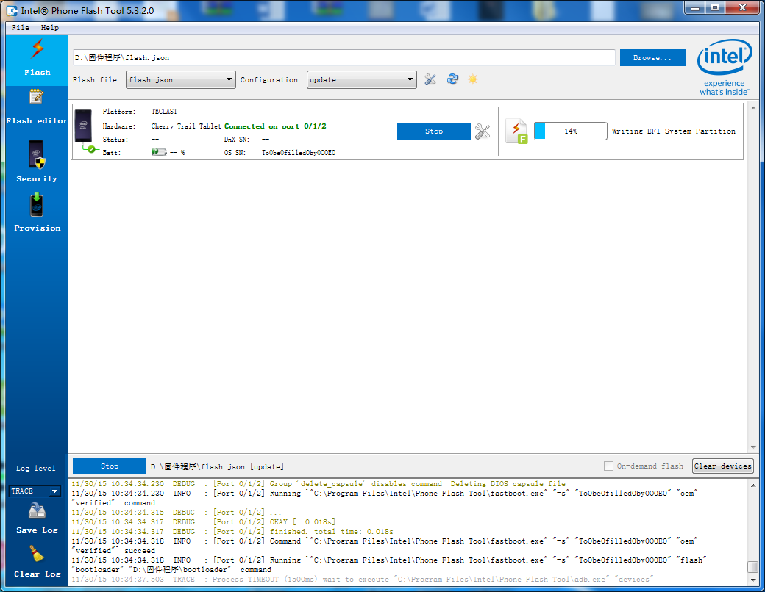

2.7 when process bar shows 100%, it means that flash is completed. Tablet will auto reboot. Remove USB cable on tablet, close the flash tool on computer. 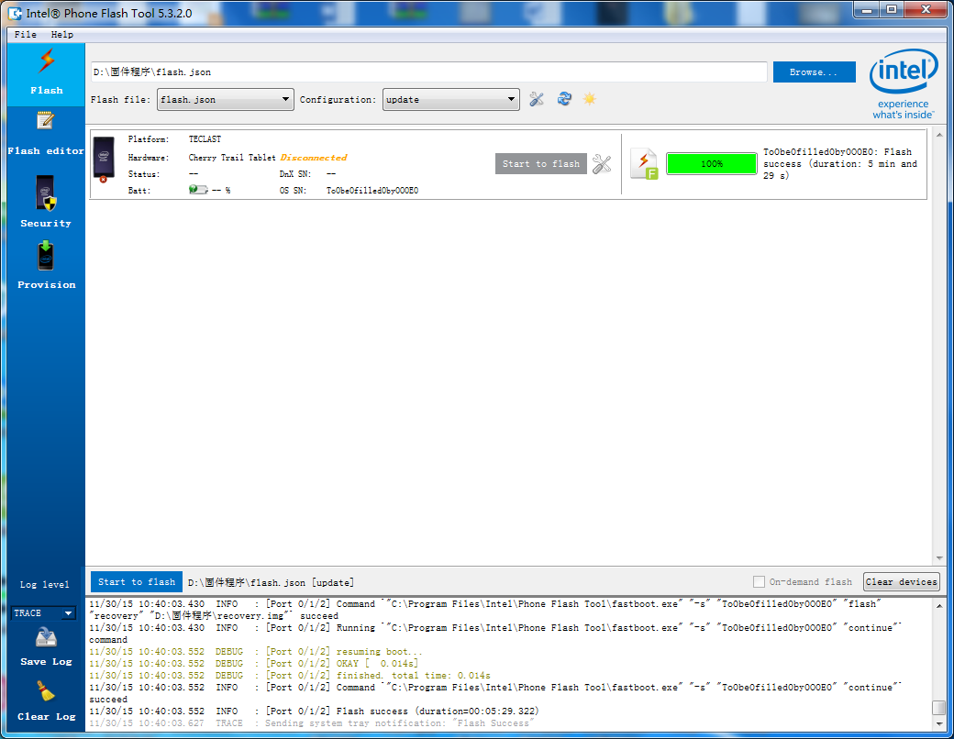

2.8 as “update mode” is like OTA update, some updates will not come into effect, so after flash, you need to recover factory defaults for once: open “settings” —》“backup and reset” —》“recover factory defaults” —》click below “recover tablet factory defaults”:
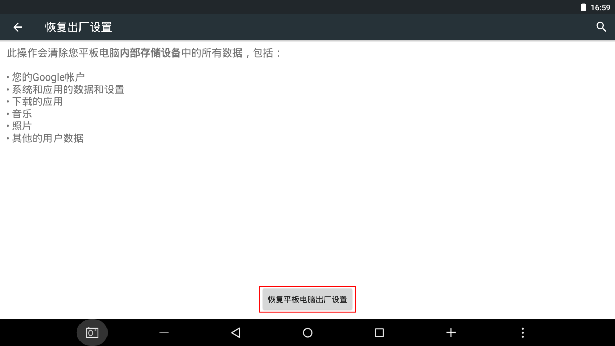

3、flashing Android os via recover mode will clear all data, including Windows and Android dual boot.

3.1 run “Phone Flash Tool”, click “Browser” button, in pop-up window load burning file “flash.json” , as below:

3.2 then rewrite “Configuration” content as “recover”, as below:
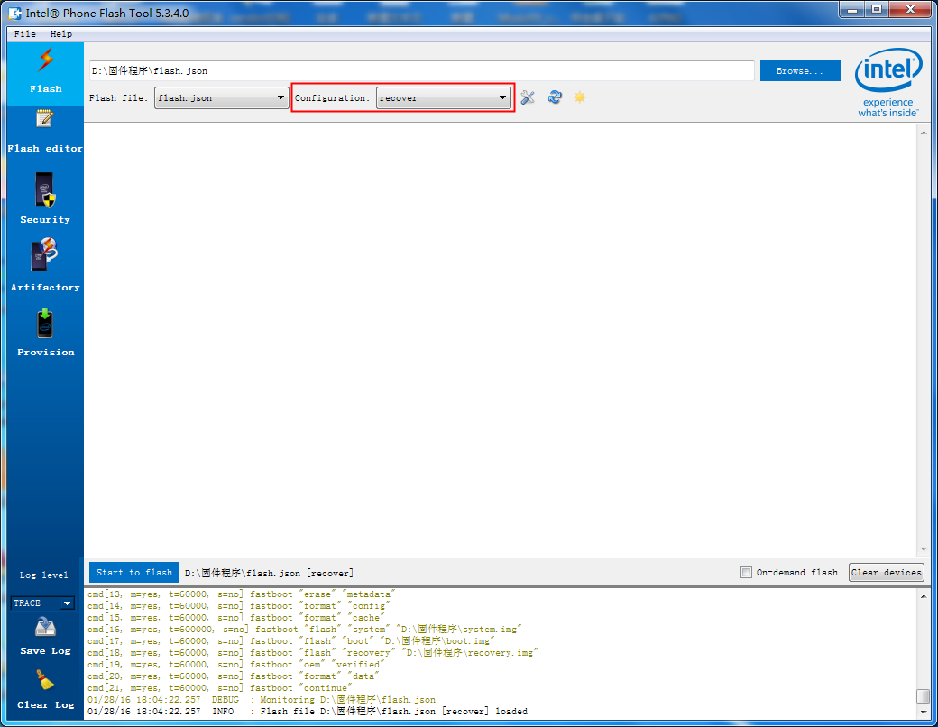

3.3 start tablet and enter Android os, shutdown. Then long-press “power + vol up + vol down” 3 buttons until “DNX FASTBOOT MODE…” words appear, as below:


3.4 connect tablet with computer, after computer recognize the device driver, flash tool will appear “Start to Flash” button, it means that tablet connects computer successfully.
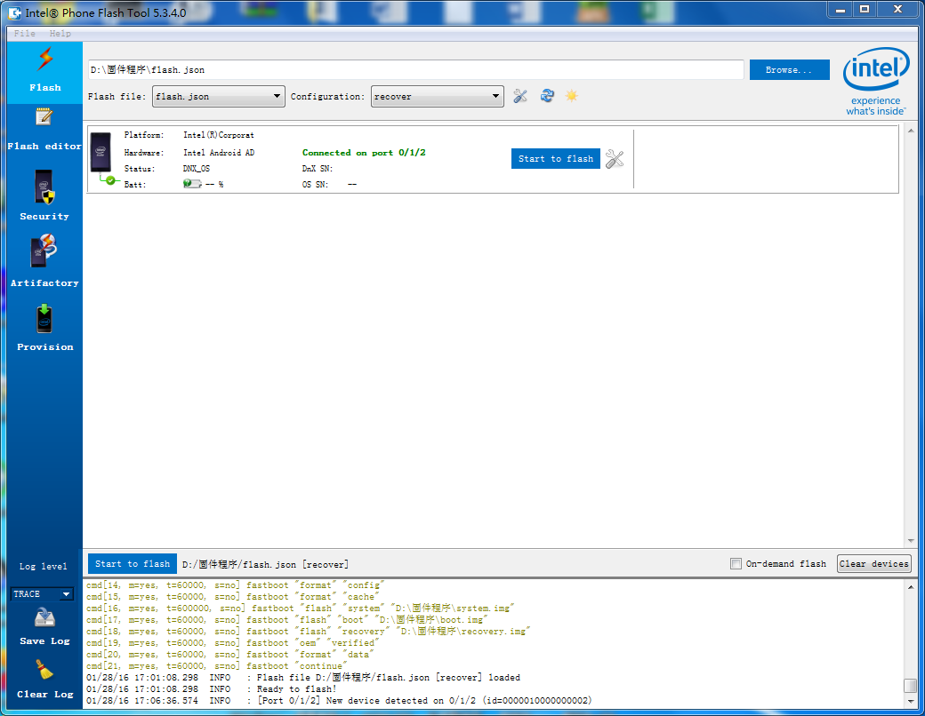

3.5 click “Start to Flash” button, it start to burn firmware.
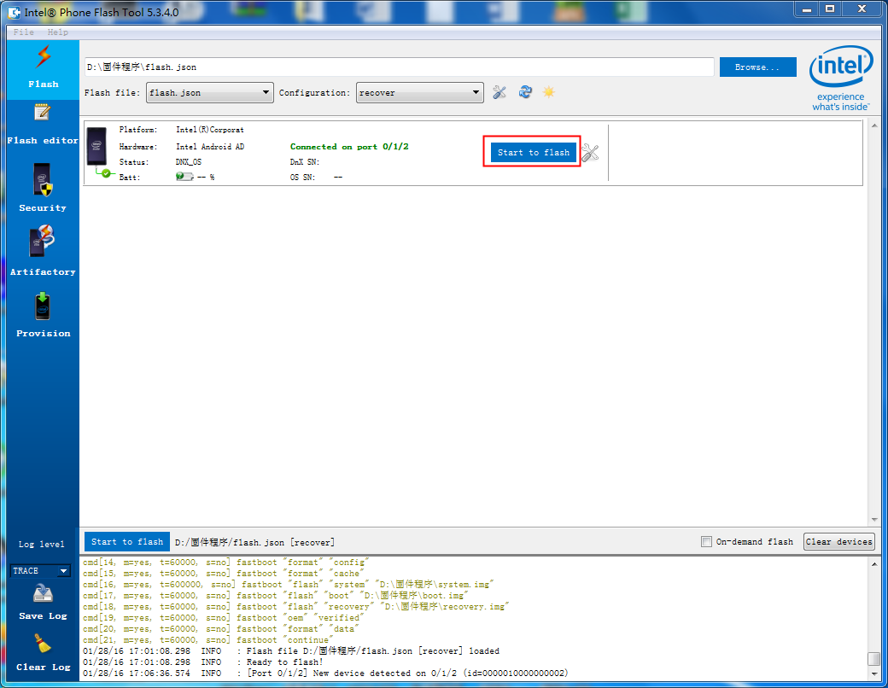
3.6 the process is as below, it will take long time, just wait patiently. Don’t do other unnecessary operations in process.
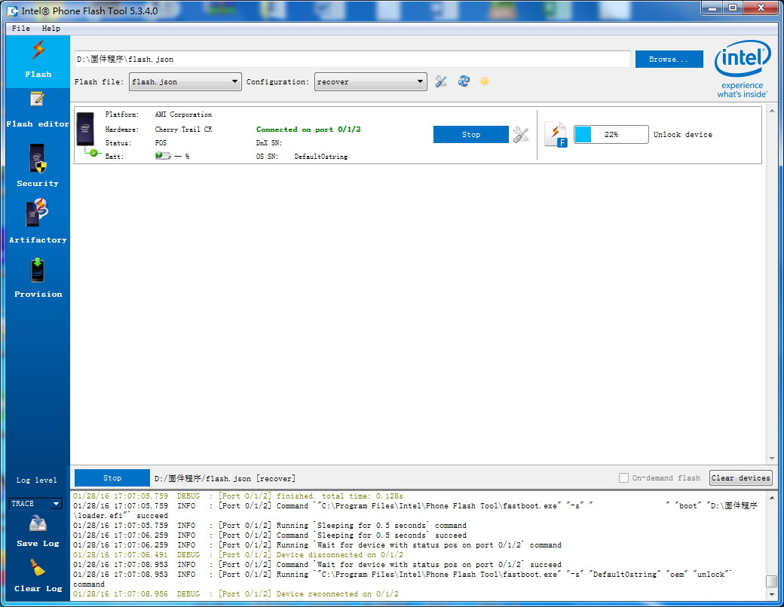

3.7 when process bar shows 100%, it means that flash is completed. Tablet will auto reboot. Remove USB cable on tablet, close the flash tool on computer.
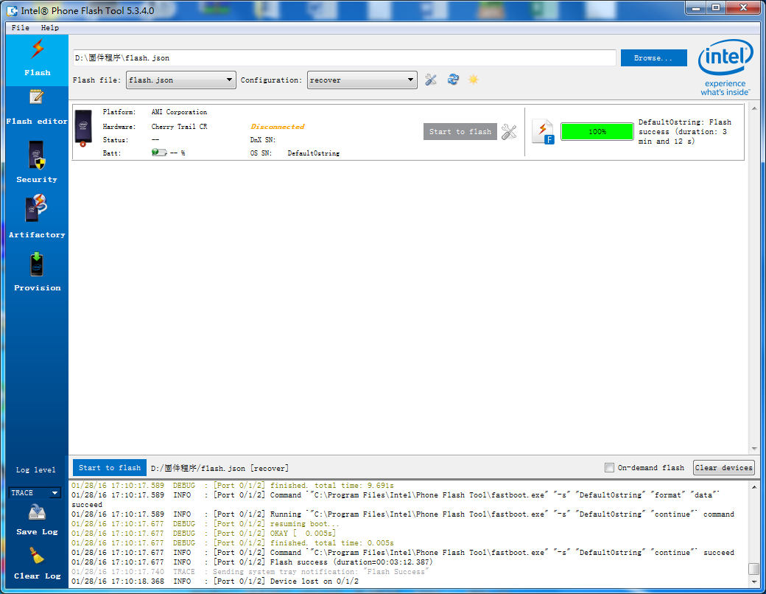

二、Flash Windows os

1, make WinPE startup disk
1.1 plug the U disk into computer and format it:
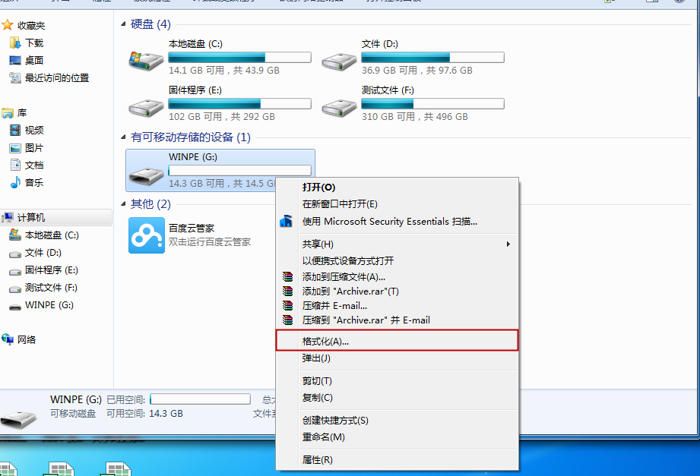

1.2 in the format menu, choose FAT32 format, and rename the label as “WINPE”:

1.3 then unzip “Win10 System Files”, copy all below children files into U disk root directory: 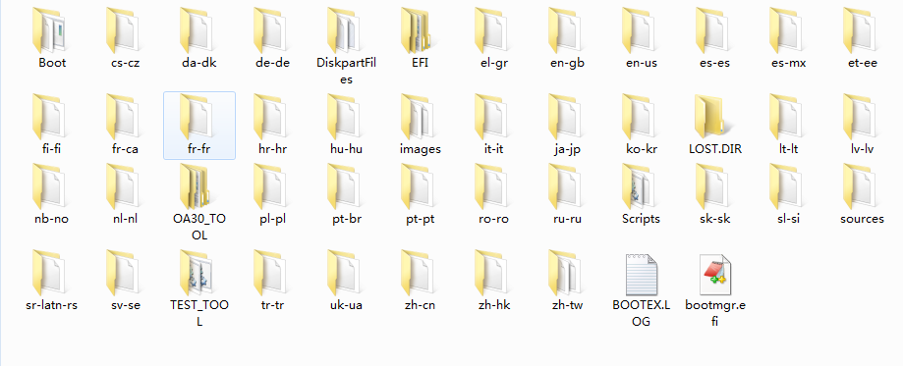

2, if tablet is with dual boot, please operate as below.

2.1 if tablet is with dual boot (boot interface has Android os and Windows os 2 kinds as below), you need to enter windows os one time. press tablet power button 3~5s to start, choose windows os in boot interface, click “OK” to enter.
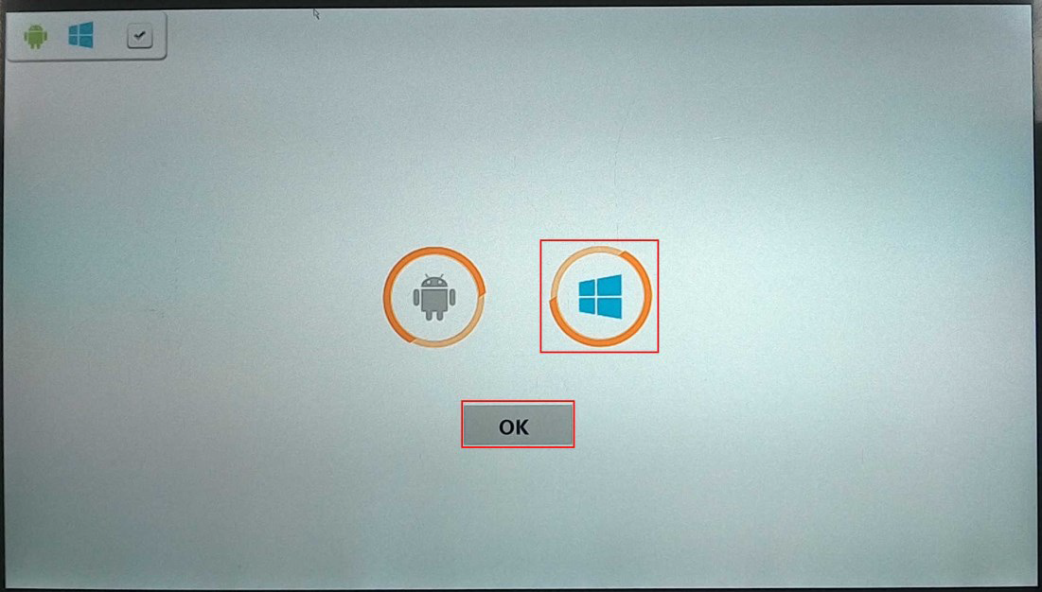
2.2 after entering, shutdown.
2.3 then connect tablet with USB HUB cable, and plug the formatted U disk, keyboard in HUB.
2.4 press tablet power button 3~5s again to boot. When screen shows TECLAST LOGO, immediately click keyboard “Delete” to enter BIOS setting interface, as below:

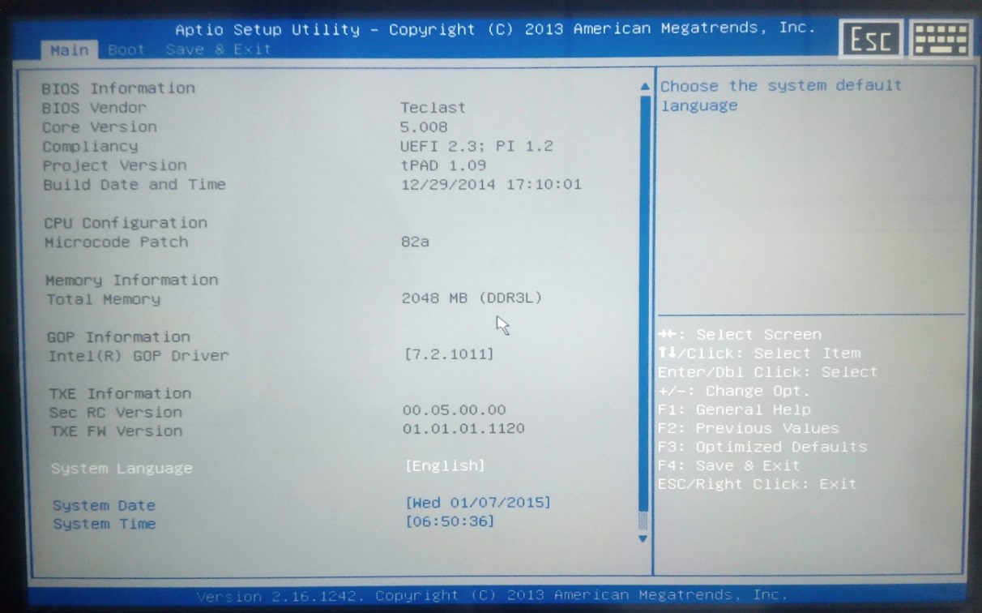
2.5 through keyboard left and right direction key, select "Save&Exit", as below: 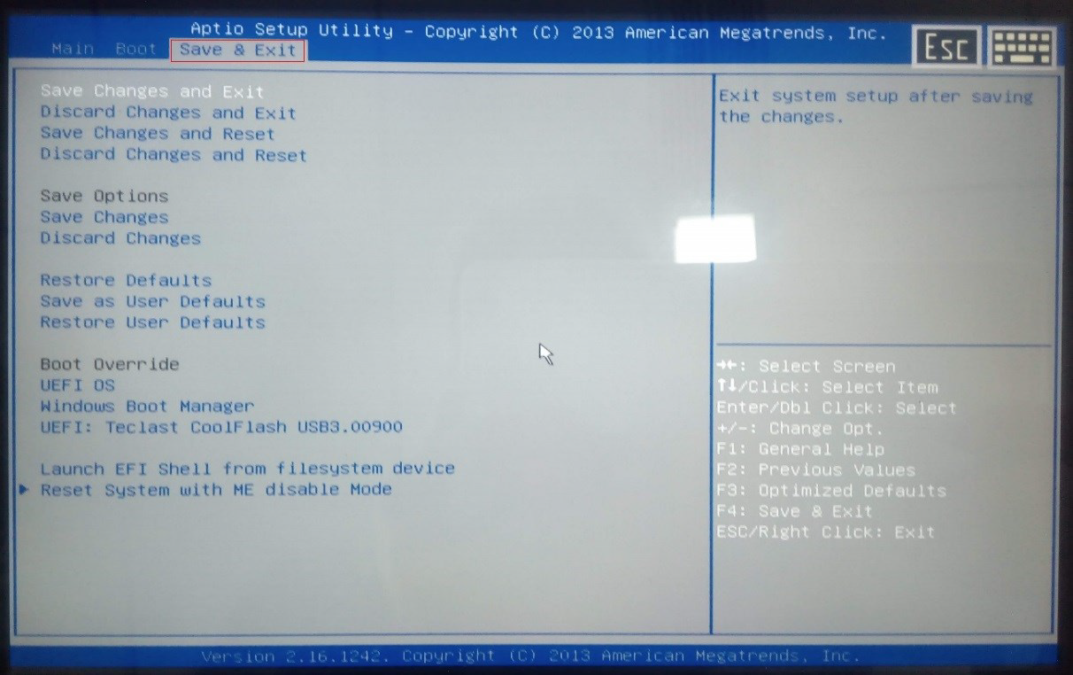

2.6 through up and down direction key, select the corresponding U disk in "Boot Override" (different U disks have different names), press “Enter” key to enter U disk boot mode. 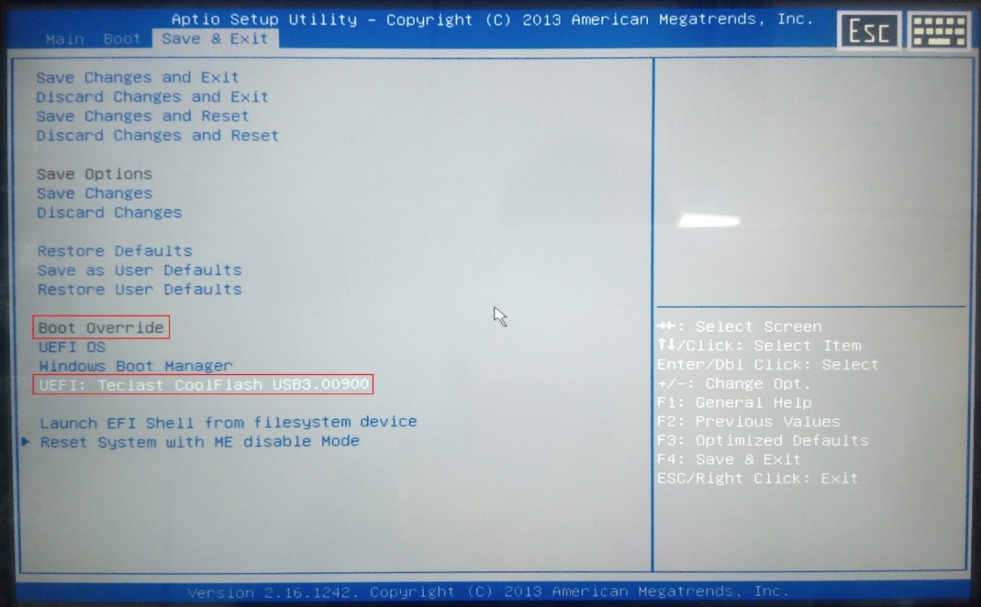

2.7 then tablet will automatically copy all Windows system files and install it, no need manual operation, as below: 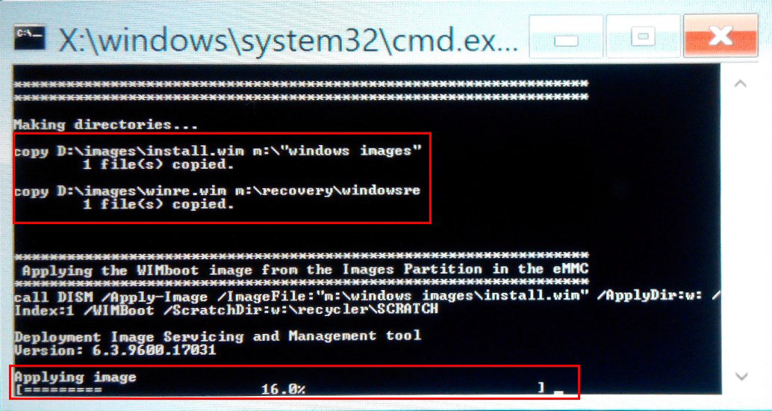

2.8 after "Operation Successful" words display, the Windows system has been reinstalled as below. now input “exit” on keyboard, click “Enter” to shutdown tablet, remove the OTG cable on tablet. 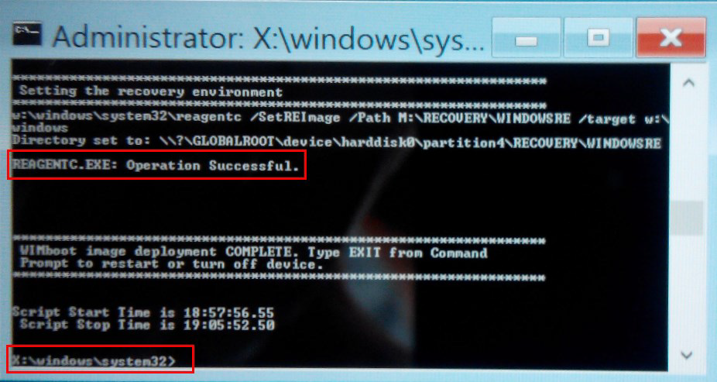

3, if tablet is only with Android os, please operate as below.

3.1 if tablet is only with Android os, as you choosed recover mode just now, boot interface will only has Android os, as below: 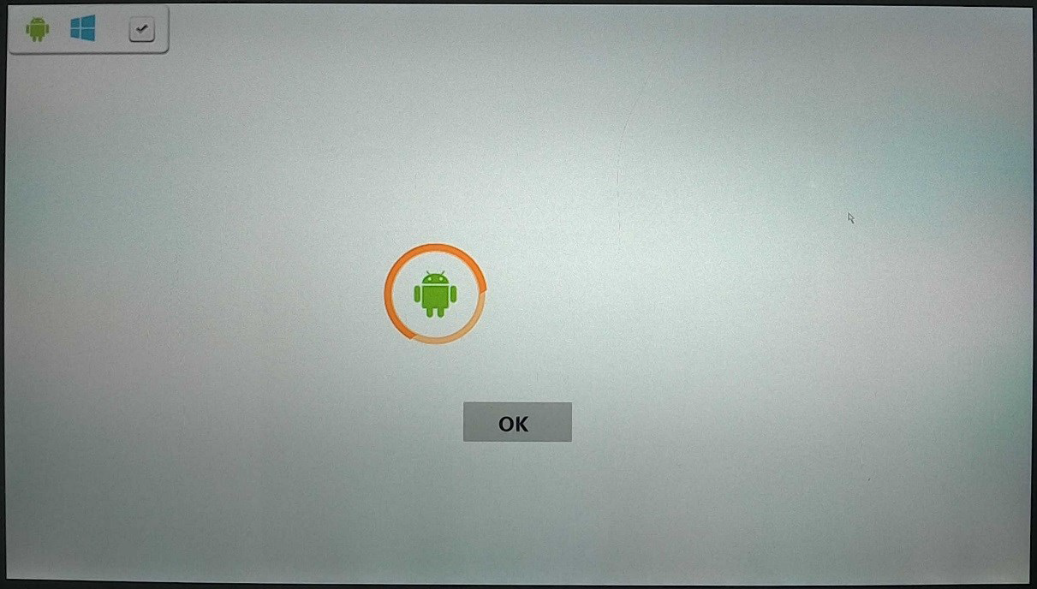

3.2 shutdown tablet. connect tablet with USB HUB cable, and plug the formatted U disk, keyboard in HUB.
3.3 press tablet power button 3~5s again to boot. When screen shows TECLAST LOGO, immediately click keyboard “Delete” to enter BIOS setting interface, as below:
3.4 through keyboard left and right direction key, select "Save&Exit", as below:

3.5 through up and down direction key, select the corresponding U disk in "Boot Override" (different U disks have different names), press “Enter” key to enter U disk boot mode.

3.6 when U disk guides to install Windows for the first time, there will be a blue screen error, such as the interface, then tablet will automatically restart.
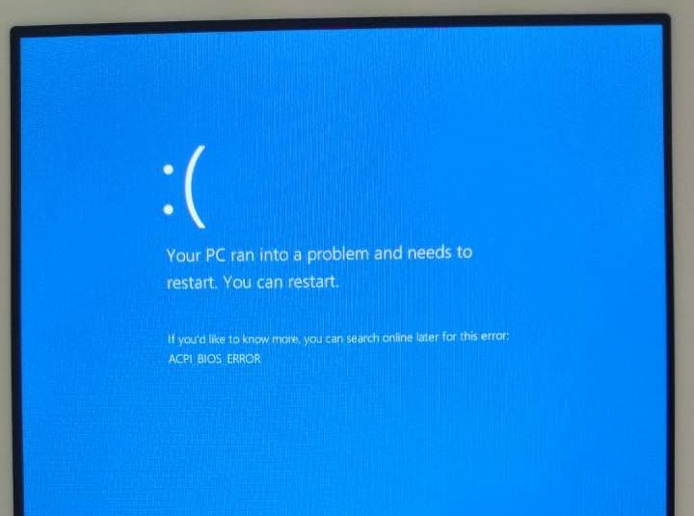

3.7 when it’s rebooting and showing TECLAST LOGO, immediately click keyboard “Delete” key, to enter BIOS settings interface, select U disk startup, and install system via U disk again. After guiding, tablet will auto reboot. When there’s TECLAST LOGO, immediately click keyboard “Delete” , namely that repeat above 3.3~3.6 steps, until below interface shows, the guide is successful (it needs to guide 3 times).
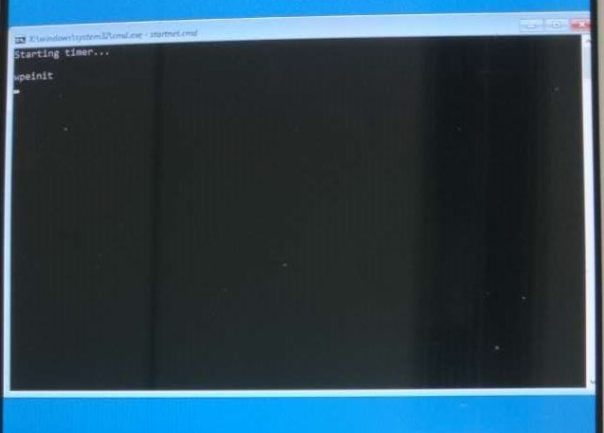

3.8 after successful guiding, tablet will enter U disk startup mode, it will auto copy all Windows system files, no need manual operation. The process is as below:
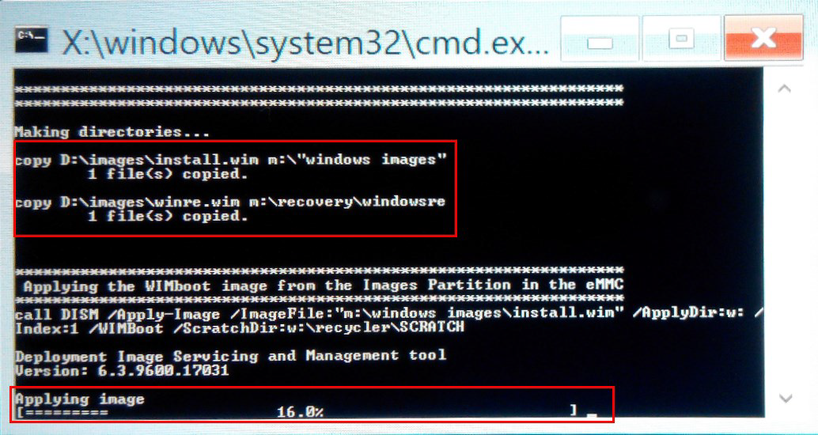

3.9 after showing “Operation Successful”, Windows system have been reinstalled. Now input “exit” on keyboard, click “Delete” key to shutdown tablet. Remove OTG cable on tablet.

4, when booting, select corresponding system to enter.

Thanks for your support !!!

